TECHNICAL APPENDIX 5.9: RESIDENTIAL VISUAL AMENITY ASSESSMENT
1.1 Purpose of the Residential Visual Amenity Assessment 0
1.2 Scope of Residential Amenity Considered 0
1.3 Relationship to Planning and Decision-Making 0
2.1 Overview of Approach 1
2.2 Step 1 – Definition of the Study Area and Scope 1
2.3 Step 2 – Evaluation of Baseline Residential Visual Amenity 1
2.4 Step 3 – Assessment of Likely Change to Residential Visual Amenity 2
2.5 Step 4 – Residential Visual Amenity Threshold Judgement 2
Table 1: Property 1: Killocraw Farm and Cottage 3
Table 2: Property No 2: Tighnamoile 5
Table 3: Property No 3: Tangy Moil Farm 7
Table 4: Property No 4: Gobagrennan Cottage 9
Table 5: Property No 5: Tigh na Mara 11
Table 6: Property No 6: Killarow Farm 13
Table 7: Property No 7: Maleen 15
Table 8: Property No 8: Killarow Cottage 17
Table 9: Property No 9: 1 Tangy Cottage 19
Table 10: Property No 10: Drumalea Farm Cottage 21
Table 11: Property No 11: Tangy Smithy 23
Table 12: Property No 12: Tangy Mill 25
Table 13: Property No 13: Tangy Mill Croft 27
Table 14: Property No 14: Tangy Farm 29
Table 15: Property No 15: Tangy Lea Cottage 31
Table 16: Property No 16: Drumalea Farm 33
Table 17: Property No 17: Dalnaspidal / Hazel’s Cottage 35
Table 18: Property No 18: Breakachy (Number 4) 37
Table 19: Property No 19: Breakachy House 39
Table 20: Property No 20: Breakachy (Number 5) 41
Table 21: Property No 21: Breakachy (Number 6) 43
Table 22: Property No 22: High Ballevain Farm 45

Technical Appendix 5.9: Residential Visual Amenity Assessment

Introduction

Purpose of the Residential Visual Amenity Assessment
    - This Residential Visual Amenity Assessment (RVAA) has been undertaken by ASH design + assessment Ltd (ASH), Chartered Landscape Architects to assess the potential effects of the Proposed Varied Development on private views and residential visual amenity.
    - The RVAA has been prepared with reference to the Landscape Institute’s Technical Guidance Note 2/19: Residential Visual Amenity Assessment (2019) (TGN 2/19). In line with this guidance, the RVAA is informed by the findings of the LVIA and applies a structured methodology grounded in GLVIA3 principles and professional judgement.
    - The Landscape and Visual Impact Assessment (LVIA) has been prepared in accordance with the Guidelines for Landscape and Visual Impact Assessment, 3rd Edition (GLVIA3) and considers effects on publicly accessible views and public visual amenity. The RVAA represents a supplementary stage beyond the LVIA, focusing specifically on if “the effect of the development on Residential Visual Amenity is of such nature and / or magnitude that it potentially affects 'living conditions' or 'Residential Amenity'” by examining views experienced from private residential properties including their gardens and curtilage.

Scope of Residential Amenity Considered
    - Residential amenity comprises a range of factors affecting living conditions, including visual amenity, noise and shadow flicker. This RVAA is concerned solely with effects on residential visual amenity. Other components of residential amenity are considered separately within the Environmental Impact Assessment Report (EIA Report) and are not addressed further within this RVAA.

Relationship to Planning and Decision-Making
    - The RVAA is undertaken to inform the planning process. It is widely recognised that the planning system operates in the public interest, and that there is no private right to a particular view. Accordingly, the presence of significant effects on views from residential properties does not automatically indicate an unacceptable outcome in planning terms.
    - However, there may be circumstances where the effect on the outlook or visual amenity of a residential property is so severe that it is not generally considered to be in the public interest to permit such conditions where they did not previously exist. The RVAA therefore seeks to identify whether effects approach or exceed the Residential Visual Amenity Threshold (RVAT).
    - The RVAA confines itself to a professional judgement on residential visual amenity only. Any conclusions regarding overall residential amenity or planning balance remain matters for the decision-maker.

Methodology

Overview of Approach
    - The RVAA follows the four-step process set out in TGN 2/19, informed by the principles, terminology and structured approach to professional judgement established within GLVIA3 and applied in line with the LVIA methodology set out in Technical Appendix 5.1.
    - The steps are:
- Definition of the study area and scope of the assessment;
- Evaluation of baseline residential visual amenity;
- Assessment of likely magnitude of change to residential visual amenity; and
- Formation of a judgement as to whether the magnitude of change reaches the RVAT.
    - Each step is described below.

Step 1 – Definition of the Study Area and Scope
    - The first stage establishes the geographical extent of the RVAA study area and identifies residential properties with the potential to experience effects on visual amenity.
    - In accordance with TGN 2/19, RVAA study areas are defined on a case-by-case basis and should be proportionate to the scale and nature of the development and the surrounding landscape context. Simply being able to see a development is not in itself sufficient justification for inclusion within an RVAA.
    - A study area extending to approximately 2km from the outermost turbines has been adopted for the Proposed Varied Development. This has been informed by the Zone of Theoretical Visibility (ZTV) analysis prepared as part of the LVIA and professional judgement regarding the likelihood of effects approaching the RVAT.
    - Residential properties within this area were identified through desk study and verified through field survey. Only properties with potential residential occupation have been included. Properties with no theoretical visibility of the Proposed Varied Development have been scoped out of further assessment.

Step 2 – Evaluation of Baseline Residential Visual Amenity
    - Baseline residential visual amenity has been established through a combination of desk study and field survey, consistent with the approach used to establish baseline conditions within the LVIA.
    - For each property included within the RVAA, baseline visual amenity has been assessed in the round, having regard to the combined experience of views from:
- the dwelling;
- the associated garden and domestic curtilage; and
- private access routes to and from the property.
    - The assessment considers the nature, extent and composition of existing views, including the presence of landform, vegetation, built features and existing wind energy development within the surrounding landscape. Primary and secondary views were identified where this information was available and relevant. Greater weight is generally attached to views from principal living rooms and main garden areas.
    - Site surveys have been undertaken from private properties where possible with the permission of occupants. Otherwise, site surveys were undertaken from publicly accessible locations only. A standardised assessment record has been prepared for each property, supported by mapping, aerial imagery and field observations.

Step 3 – Assessment of Likely Change to Residential Visual Amenity
    - The third stage assesses the likely change to residential visual amenity resulting from the Proposed Varied Development, following the methodology and criteria used within the LVIA assessment (see Technical Appendix 5.1).
    - Residents at their place of residence are generally recognised as high-sensitivity visual receptors, reflecting both the value attached to private views and the duration over which those views are likely to be experienced.
    - The assessment of magnitude of change takes account of factors including:
- distance of the property from the Proposed Varied Development;
- scale, number and extent of turbines visible;
- the position of the Proposed Varied Development within the view;
- effects on the composition, focus and balance of the existing view;
- the degree of contrast or integration with existing landscape and visual elements;
- duration and permanence of effects; and
- the influence of any mitigation, including landform or vegetation screening.
    - Sensitivity and magnitude are considered together to determine the significance of visual effects on residential visual amenity.
    - The purpose of Step 3 is to identify those properties experiencing the highest magnitude of change which may require further consideration under Step 4.

Step 4 – Residential Visual Amenity Threshold Judgement
    - Step 4 involves a more detailed examination of predicted effects at those properties identified as experiencing the greatest magnitude of change.
    - This stage represents a distinct judgement beyond the assessment of EIA significance and considers whether the magnitude of change in visual amenity is such that it could reasonably be regarded as rendering a property an unattractive place in which to live (‘the Lavender Test’).
    - The RVAT judgement is expressed through clear narrative, drawing on professional judgement and plain language descriptors where appropriate. For the RVAT to be reached and visual amenity to be harmed the turbines would have to lead to an overbearing or overwhelming effect on the property such that it would become an unattractive place in which to live.
    - Identification of effects that reach or approach the RVAT does not imply a conclusion on acceptability. Rather, it identifies a matter for consideration by the decision-maker alongside other material planning considerations.

Table 1: Property 1: Killocraw Farm and Cottage
Property 1: Killocraw Farm and Cottage
Grid Reference: 166066 630669  Elevation: 62.7m |  | Distance to Nearest Visible Turbine: 1.68km  Blade Tips Theoretically Visible: 10  Hubs Theoretically Visible: 4
Property Description
☐ Detached  ☒ Semi-detached  ☐ Terraced  ☒ Farmhouse | ☐ 1 Storey  ☒ 2 Storey  ☐ Stone Built  ☒ Rendered | ☒ Farmyard  ☒ Outbuildings  ☐ Conservatory  ☐ Garages |  | ☐ Front Garden  ☒ Rear Garden  ☐ Side Garden
Description of Baseline Visual Amenity  These properties overlook an active and well used farmyard with south-easterly views contained by rolling agricultural land. The Operational Development turbines are not currently visible from the properties or farmyard. Views from the farmhouse are largely oriented westwards towards the sea rather than inland.  Nature of Change  The blades and hubs of the Proposed Varied Development would be visible on the skyline to the south and east over the rolling farmland. Views towards the turbines from within the farmhouse are completely screened by barns and other farm buildings. Views of the turbines from the farmyard would be partially screened by the intervening landform. The aviation lights of two turbines would be theoretically visible during the hours of darkness.  Magnitude of Change: Medium  Significance of Effect: Significant |  |  | Residential Visual Amenity Threshold Assessment  Main views from the properties are to the west overlooking the sea. Views to the south and east are largely screened by farm buildings. While significant effects were identified, due to potential views from the farmyard, the Proposed Varied Development would not form a dominant feature in views from the dwellings. The Proposed Varied Development would not overwhelm views and it is considered that the effects do not reach the RVAT.
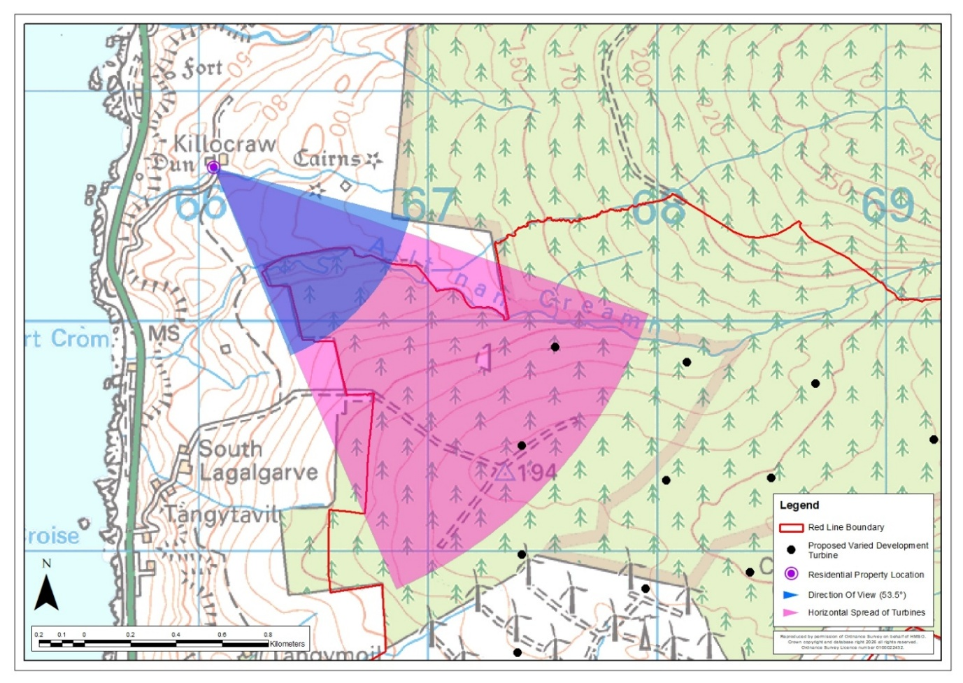
Killocraw Farm – Location Plan
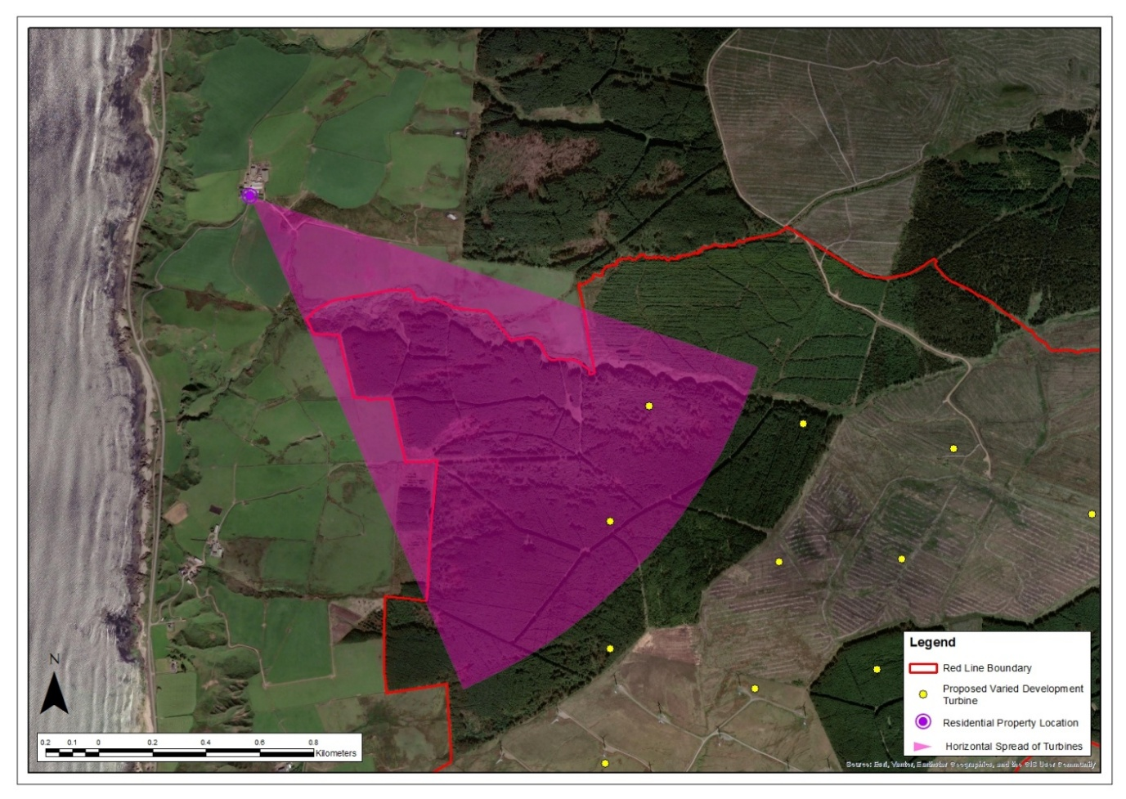
Killocraw Farm – Aerial Image

Table 2: Property No 2: Tighnamoile
Property No 2: Tighnamoile
Grid Reference: 166247 628589  Elevation: 107.7m |  | Distance to Nearest Visible Turbine: 1.07km  Blade Tips Theoretically Visible: 16  Hubs Theoretically Visible: 10
Property Description
☒ Detached  ☐ Semi-detached  ☐ Terraced  ☐ Farmhouse | ☐ 1 Storey  ☒ 2 Storey  ☐ Stone Built  ☒ Rendered | ☐ Farmyard  ☐ Outbuildings  ☐ Conservatory  ☐ Garages |  | ☒ Front Garden  ☐ Rear Garden  ☒ Side Garden
Description of Baseline Visual Amenity  The front of the property looks eastward out over farmland and a disused farm building directly at the Operational Development. Conifers in the midground provide some screening of more distant turbines. Views from the rear of the property and back garden are to the west towards the sea in the opposite direction to the existing turbines  Nature of Change  The Proposed Varied Development turbines would be clearly visible in main views from the front garden and the front of the dwelling. They would replace the existing turbines in these views appearing noticeably larger. The aviation lights of two turbines would be theoretically visible during the hours of darkness.  Magnitude of Change: Medium - high  Significance of Effect: Significant |  |  | Residential Visual Amenity Threshold Assessment  The Proposed Varied Development turbines would feature prominently in views from the front of the dwelling and front garden. They would be seen within a similar part of the view as the Operational Development turbines which they would replace. The turbines would be prominent but would not introduce new features into views east. While this would represent a significant effect, it is not considered to reach the RVAT.
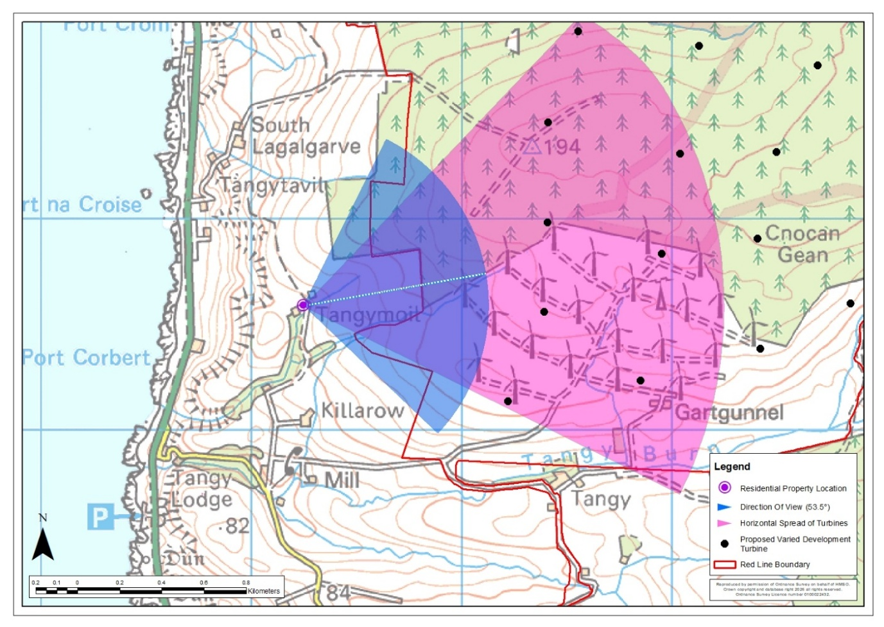
Tighnamoile – Location Plan
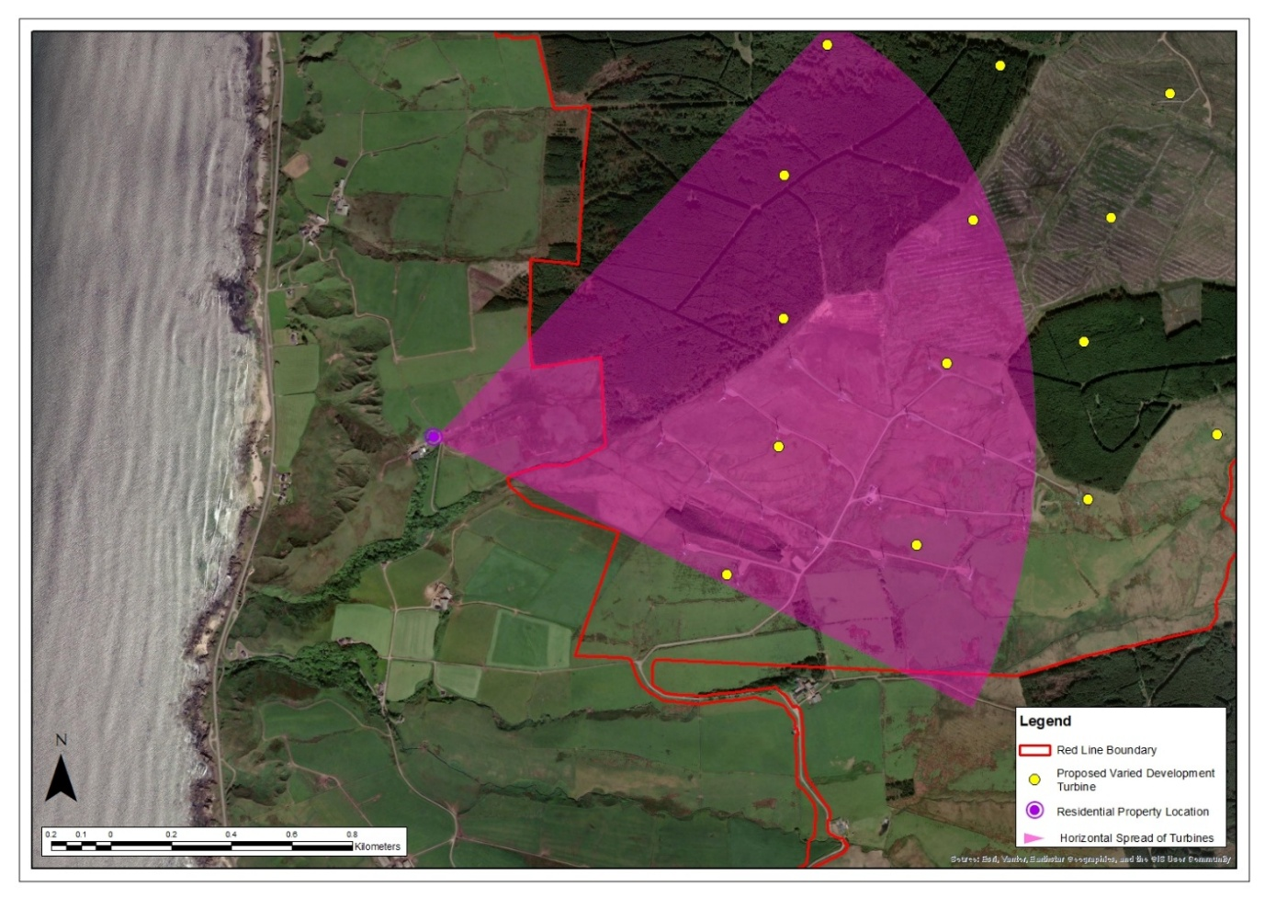
Tighnamoile – Aerial Image

Table 3: Property No 3: Tangy Moil Farm
Property No 3: Tangy Moil Farm
Grid Reference: 166219 628562  Elevation: 104.8m |  | Distance to Nearest Visible Turbine: 1.08km  Blade Tips Theoretically Visible: 11  Hubs Theoretically Visible: 5
Property Description
☒ Detached  ☐ Semi-detached  ☐ Terraced  ☒ Farmhouse | ☒ 1.5 Storey  ☐ 2 Storey  ☐ Stone Built  ☐ Rendered | ☒ Farmyard  ☒ Outbuildings  ☐ Conservatory  ☐ Garages |  | ☒ Front Garden  ☒ Rear Garden  ☒ Side Garden
Description of Baseline Visual Amenity  Views north and east from this property are occupied by a very active farmyard in the foreground with the Operational Development turbines featuring in the midground across agricultural land. Farm buildings screen views westward while deciduous trees provide some screening from the front windows of the property. The property sits in a slight dip in the landscape which somewhat limits views outwards.  Nature of Change  The Proposed Varied Development turbines would be seen in side views replacing the Operational Development turbines and appearing noticeably larger. Intervening deciduous trees would provide some screening. The aviation lights of two turbines would be theoretically visible during the hours of darkness.  Magnitude of Change: Medium  Significance of Effect: Significant |  |  | Residential Visual Amenity Threshold Assessment  The Proposed Varied Development turbines would feature in side views from the dwelling and from the front garden. They would be seen within a similar part of the view as the Operational Development turbines which they would replace. While this would represent a significant effect, it is not considered to reach the RVAT. The turbines would be noticeable but would be partially screened by existing vegetation and intervening landform. They would not introduce new features into views east or dominate the visual amenity of the property.
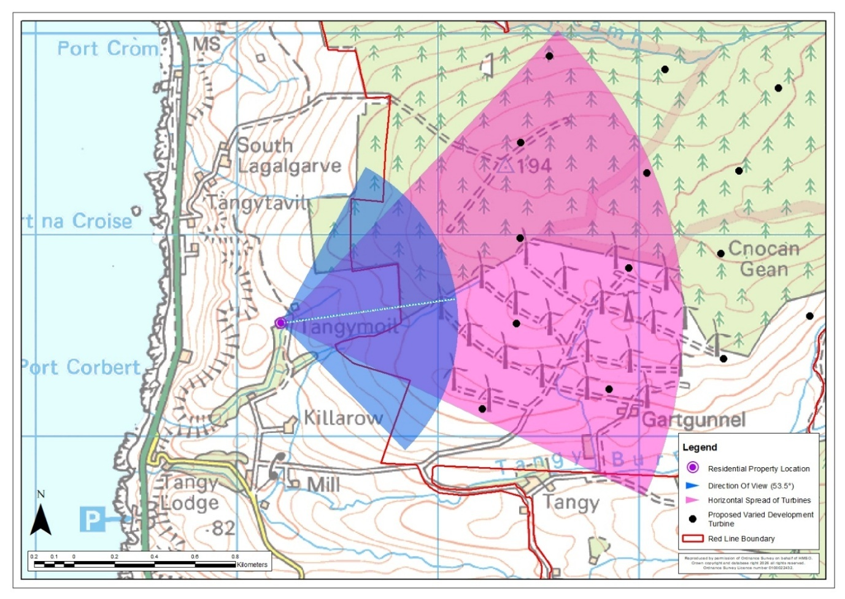
Tangy Moil Farm – Location Plan
Tangy Moil Farm – Aerial Image
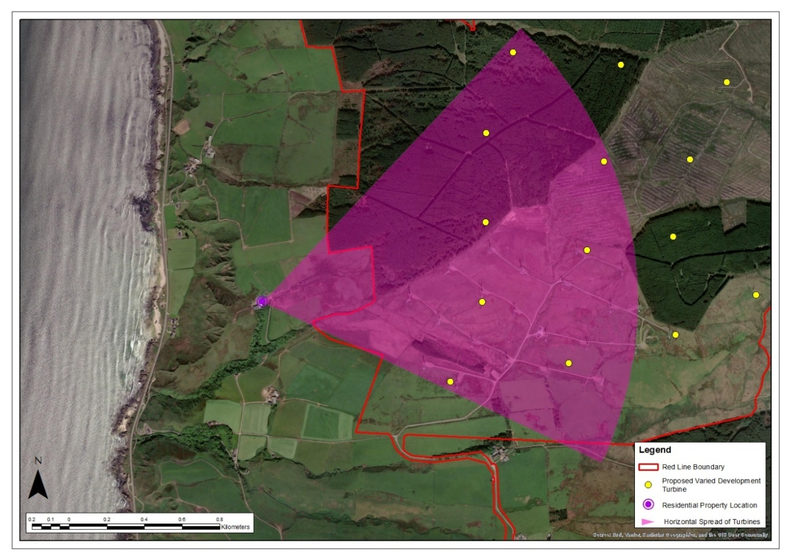

Table 4: Property No 4: Gobagrennan Cottage
Property No 4: Gobagrennan Cottage
Grid Reference: 170598 628580  Elevation: 136.4m |  | Distance to Nearest Visible Turbine: 1.65km  Blade Tips Theoretically Visible: 11  Hubs Theoretically Visible: 5
Property Description
☒ Detached  ☐ Semi-detached  ☐ Terraced  ☐ Farmhouse | ☒ 1 Storey  ☐ 2 Storey  ☐ Stone Built  ☒ Rendered | ☐ Farmyard  ☒ Outbuildings  ☐ Conservatory  ☐ Garages |  | ☒ Front Garden  ☒ Rear Garden  ☐ Side Garden
Description of Baseline Visual Amenity  Views from the front of the property are eastward over rough grazing land and conifer forestry with the Loch Lussa Dam appearing in northeasterly views. Rear views are largely contained by outbuildings and rising landform beyond.  Nature of Change  The Proposed Varied Development turbines would be seen to the west in rear garden views between gaps in the outbuildings. It is likely that rear views from the dwelling itself would be limited by the outbuildings. Where visible the turbines would appear as new features against the skyline, as the Operational Development turbines are not visible. The aviation light of one turbine would be theoretically visible during the hours of darkness.  Magnitude of Change: Medium  Significance of Effect: Significant |  |  | Residential Visual Amenity Threshold Assessment  The Proposed Varied Development turbines would not affect the views eastward from the front of the property and views of the turbines would likely be limited by the surrounding outbuildings. As such the turbines would not dominate the visual amenity of the property. This is not considered to reach the RVAT.
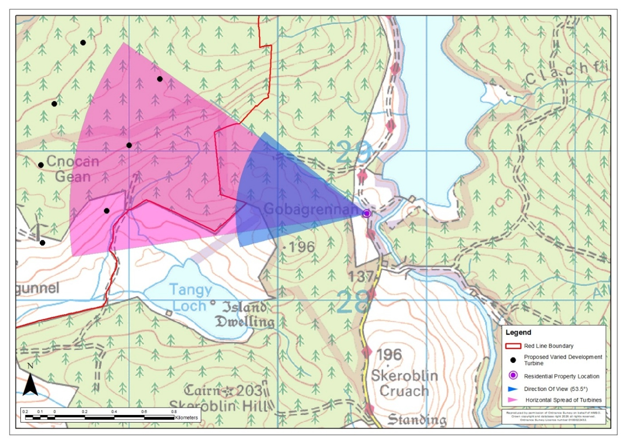
Gobagrennan Cottage – Location Plan
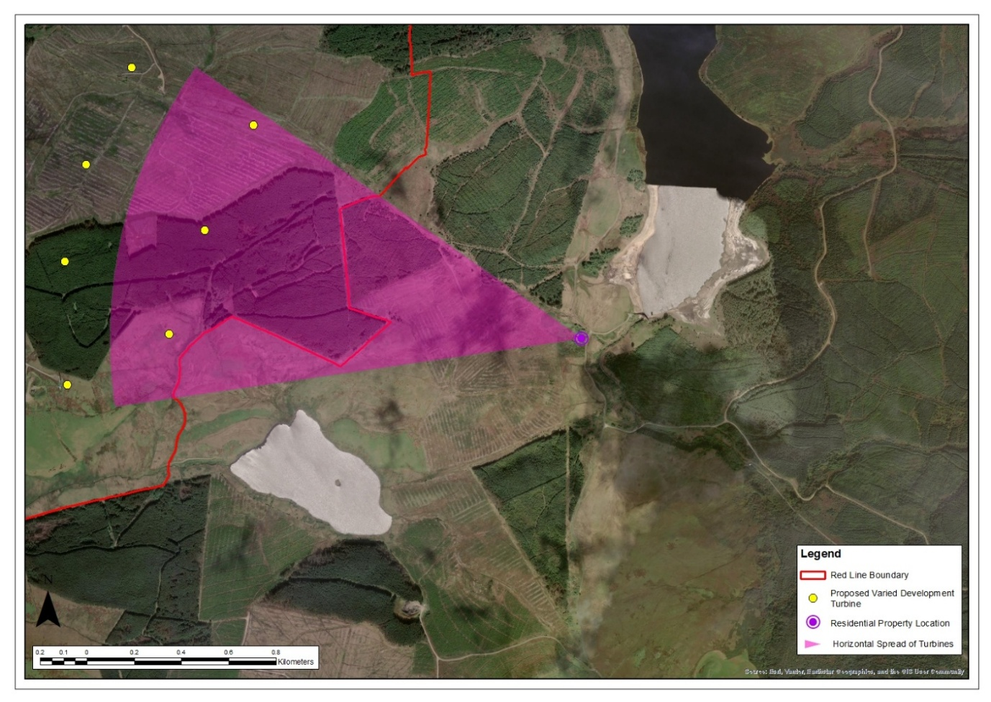
Gobagrennan Cottage – Aerial Image

Table 5: Property No 5: Tigh na Mara
Property No 5: Tigh na Mara
Grid Reference: 166083 628165  Elevation: 85.8m |  | Distance to Nearest Visible Turbine: 1.13km  Blade Tips Theoretically Visible: 16  Hubs Theoretically Visible: 10
Property Description
☒ Detached  ☐ Semi-detached  ☐ Terraced  ☐ Farmhouse | ☐ 1 Storey  ☒ 2 Storey  ☐ Stone Built  ☒ Rendered | ☐ Farmyard  ☒ Outbuildings  ☐ Conservatory  ☐ Garages |  | ☒ Front Garden  ☐ Rear Garden  ☒ Side Garden
Description of Baseline Visual Amenity  Main views from the property and the garden are westward facing the sea. The Operational Development turbines feature in side views eastward with the intervening hill providing some screening. Killowcraw Farm appears in views south-east.  Nature of Change  The Proposed Varied Development turbines would be seen in side views to the north-east replacing the Operational Development turbines and appearing noticeably larger. Intervening landform would provide some screening. The aviation lights of three turbines would be theoretically visible during the hours of darkness.  Magnitude of Change: Medium  Significance of Effect: Significant |  |  | Residential Visual Amenity Threshold Assessment  The Proposed Varied Development turbines would not affect the property’s valued views to the west towards the sea. They would feature prominently in side views eastward from the dwelling and from the front garden and driveway. They would be seen in a similar part of the view as the Operational Development turbines which they would replace. While this would represent a significant effect, it is not considered to reach the RVAT. The turbines would be prominent but would not introduce new features into views east and would not dominate the visual amenity of the property, given that valued views westward would not be affected.
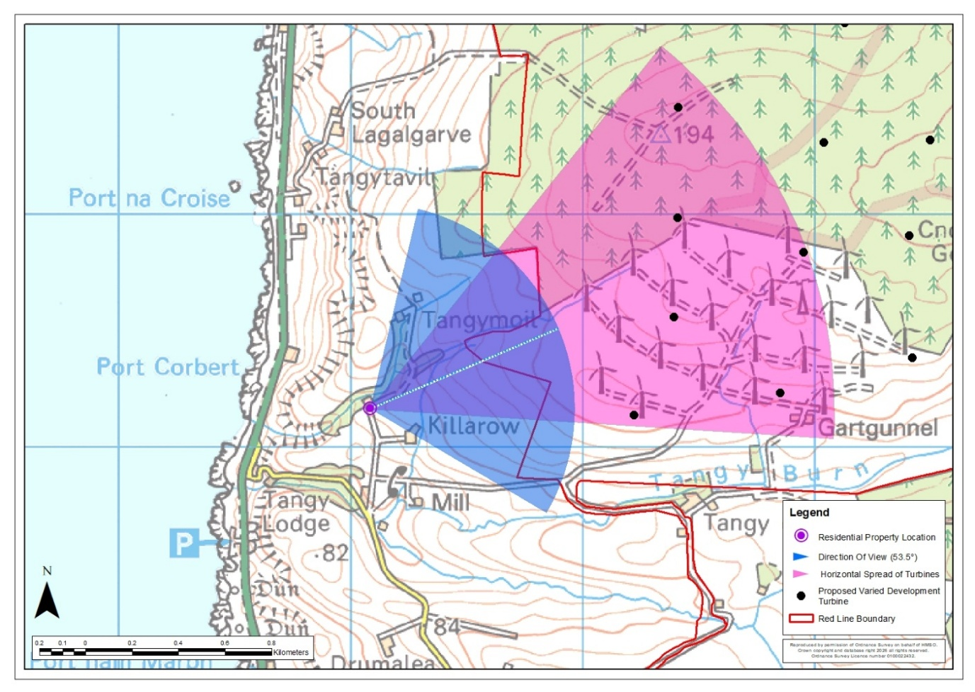
Tigh na Mara – Location Plan
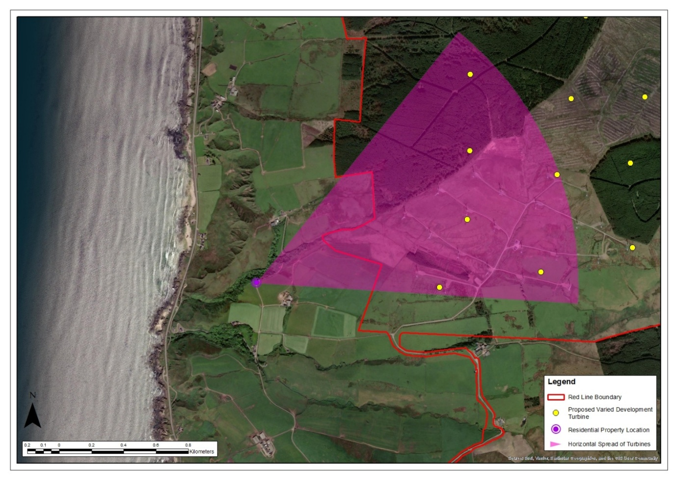
Tigh na Mara – Aerial Image

Table 6: Property No 6: Killarow Farm
Property No 6: Killarow Farm
Grid Reference: 166242 628026  Elevation: 86.9m |  | Distance to Nearest Visible Turbine: 0.98km  Blade Tips Theoretically Visible: 16  Hubs Theoretically Visible: 9
Property Description
☒ Detached  ☐ Semi-detached  ☐ Terraced  ☒ Farmhouse | ☐ 1 Storey  ☒ 2 Storey  ☐ Stone Built  ☐ Rendered | ☒ Farmyard  ☒ Outbuildings  ☐ Conservatory  ☐ Garages |  | ☒ Front Garden  ☐ Rear Garden  ☐ Side Garden
Description of Baseline Visual Amenity  The existing turbines are not visible in main views from the front of the farmhouse and front garden due to screening from farm outbuildings. These main views are to the south over agricultural land with views westward towards the sea from the garden. Rear views from the dwelling are over the farmyard with wider views contained by farm outbuildings. There would be some partially screened views of the Operational Development from the wider curtilage of the farmyard.  Nature of Change  The Proposed Varied Development turbines would be largely screened in rear views from the dwelling by farm outbuildings. Where visible from the wider curtilage of the farmyard, they would appear noticeable larger than the Operational Development turbines in views to the north-east. The aviation lights of two turbines would be theoretically visible during the hours of darkness.  Magnitude of Change: Low - medium  Significance of Effect: Not Significant |  |  | Residential Visual Amenity Threshold Assessment  The Proposed Varied Development turbines would not affect the property’s main views south or west towards the sea. They would largely be screened in rear view by intervening farm outbuildings. It is therefore considered that the effect would not reach the RVAT.
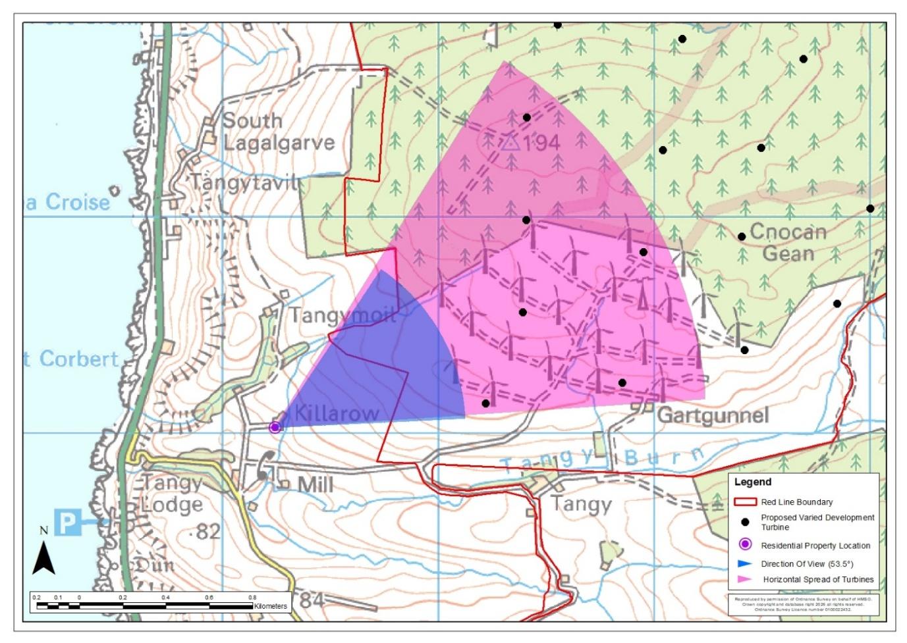
Killarow Farm – Location Plan
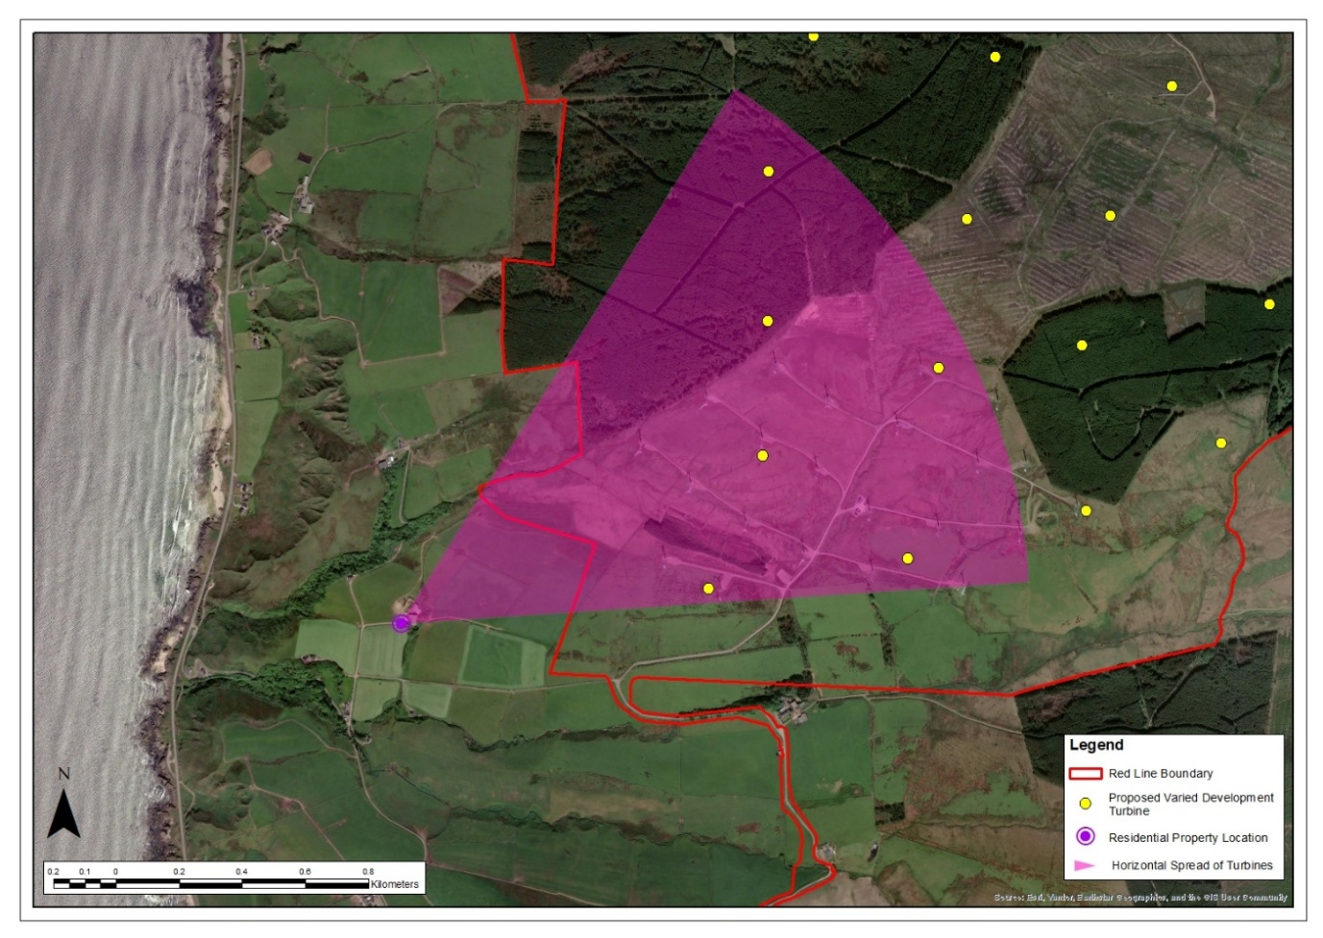
Killarow Farm – Aerial Image

Table 7: Property No 7: Maleen
Property No 7: Maleen
Grid Reference: 165956 627912  Elevation: 66.7m |  | Distance to Nearest Visible Turbine: 1.28km  Blade Tips Theoretically Visible: 16  Hubs Theoretically Visible: 10
Property Description
☒ Detached  ☐ Semi-detached  ☐ Terraced  ☐ Farmhouse | ☐ 1 Storey  ☒ 2 Storey  ☐ Stone Built  ☒ Rendered | ☐ Farmyard  ☒ Outbuildings  ☐ Conservatory  ☐ Garages | ☒ Front Garden  ☒ Rear Garden  ☒ Side Garden
Description of Baseline Visual Amenity  The front yard and driveway of the property are used for parking and as a working area, with a small outbuilding in the foreground. The property has clear views of the Operational Development turbines from the front of the house and driveway, over intervening hill and agricultural land to the east and north-east. The front garden continues around to the side of the house at the north with some low trees within the garden providing a small amount of screening. Views from the rear of the property and back garden are to the west towards the sea in the opposite direction to the Operational Development turbines.  Nature of Change  The Proposed Varied Development turbines would be visible in views from the front garden and windows at the front of the dwelling. They would replace the Operational Development turbines in these views appearing noticeably larger. The aviation lights of three turbines would be theoretically visible during the hours of darkness.  Magnitude of Change: Medium - high  Significance of Effect: Significant |  | Residential Visual Amenity Threshold Assessment  Although the Proposed Varied Development turbines would not affect the property’s valued views to the west towards the sea, they would feature prominently in views from the front of the dwelling, front garden and driveway. They would be seen within a similar horizontal field of view as the existing turbines which they would replace. While this would represent a significant effect, it is not considered to reach the RVAT. The turbines would be prominent but would not introduce new features into views east and north or dominate the visual amenity of the property, given that valued views westward would not be affected.
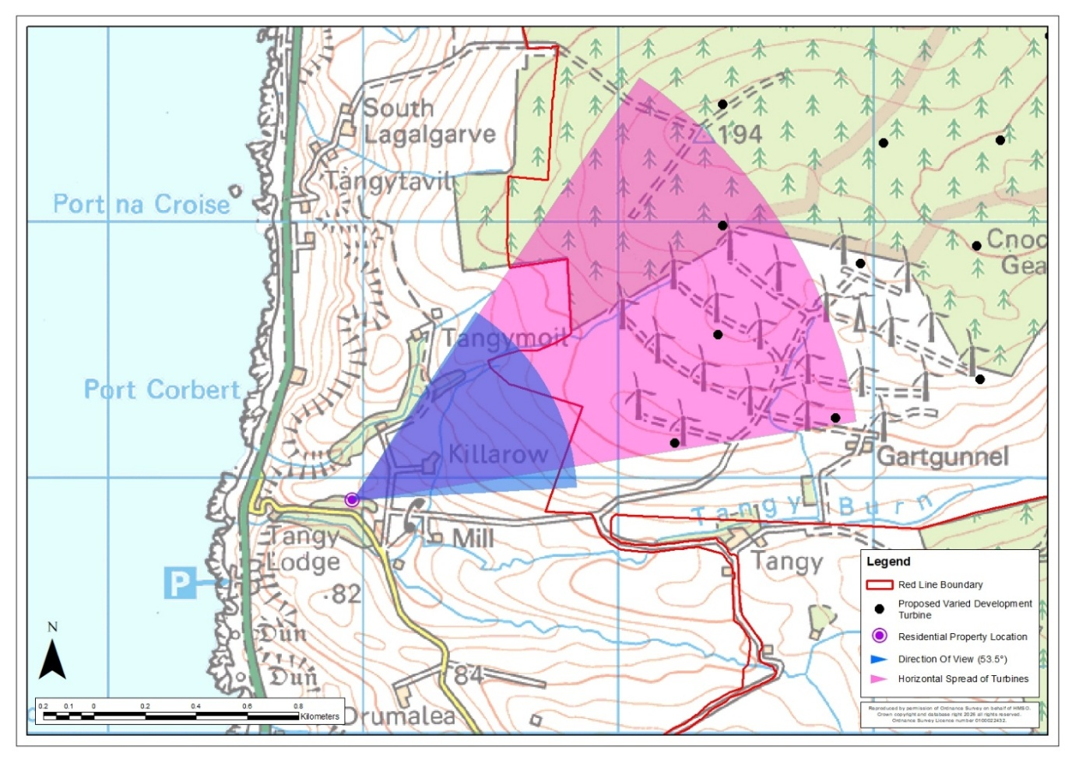
Maleen – Location Plan
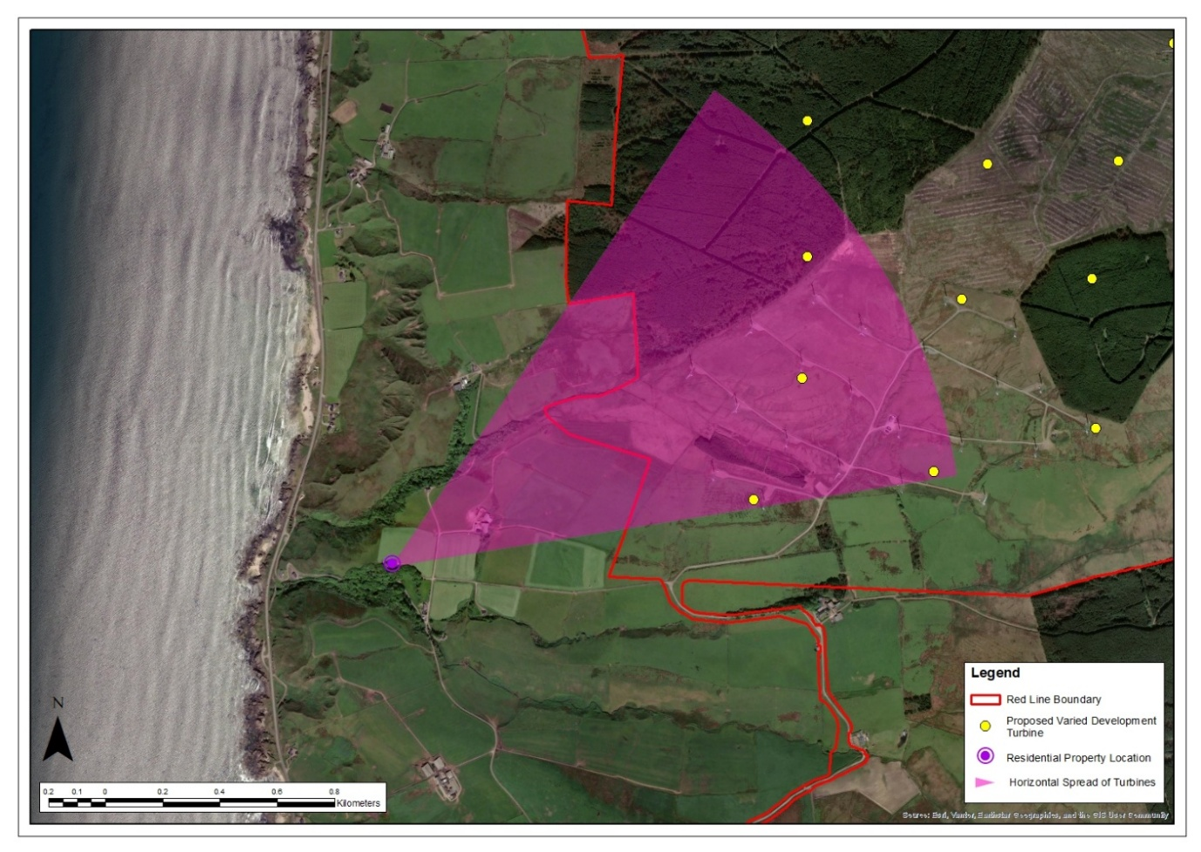
Maleen – Aerial Image

Table 8: Property No 8: Killarow Cottage
Property No 8: Killarow Cottage
Grid Reference: 166075 627769  Elevation: 50.8m |  | Distance to Nearest Visible Turbine: 1.20km  Blade Tips Theoretically Visible: 13  Hubs Theoretically Visible: 7
Property Description
☐ Detached  ☐ Semi-detached  ☒ Terraced  ☐ Farmhouse | ☒ 1 Storey  ☐ 2 Storey  ☐ Stone Built  ☒ Rendered | ☐ Farmyard  ☐ Outbuildings  ☐ Conservatory  ☐ Garages |  | ☒ Front Garden  ☒ Rear Garden  ☒ Side Garden
Description of Baseline Visual Amenity  This is the most northerly property in a line of four terraced houses. Views from the front of the property and front and side gardens are over the access road and agricultural land towards the Operational Development turbines which occupy the hill and skyline to the northeast. Views westward are over the rear garden onto mature deciduous trees that line Tangy Burn.  Nature of Change  The Proposed Varied Development turbines would be clearly visible in views from the front garden and the front of the property including kitchen windows. They would replace the existing turbines in views to the northeast appearing noticeably larger. The aviation lights of two turbines would be theoretically visible during the hours of darkness.  Magnitude of Change: Medium - high  Significance of Effect: Significant |  |  | Residential Visual Amenity Threshold Assessment  The Proposed Varied Development turbines would be clearly visible from the front of the property replacing the Operational Development turbines. While they would be prominent, they would not introduce new features into views northeast and would not dominate the visual amenity of the property as rear views westward would remain unaffected. This is not considered to reach the RVAT.
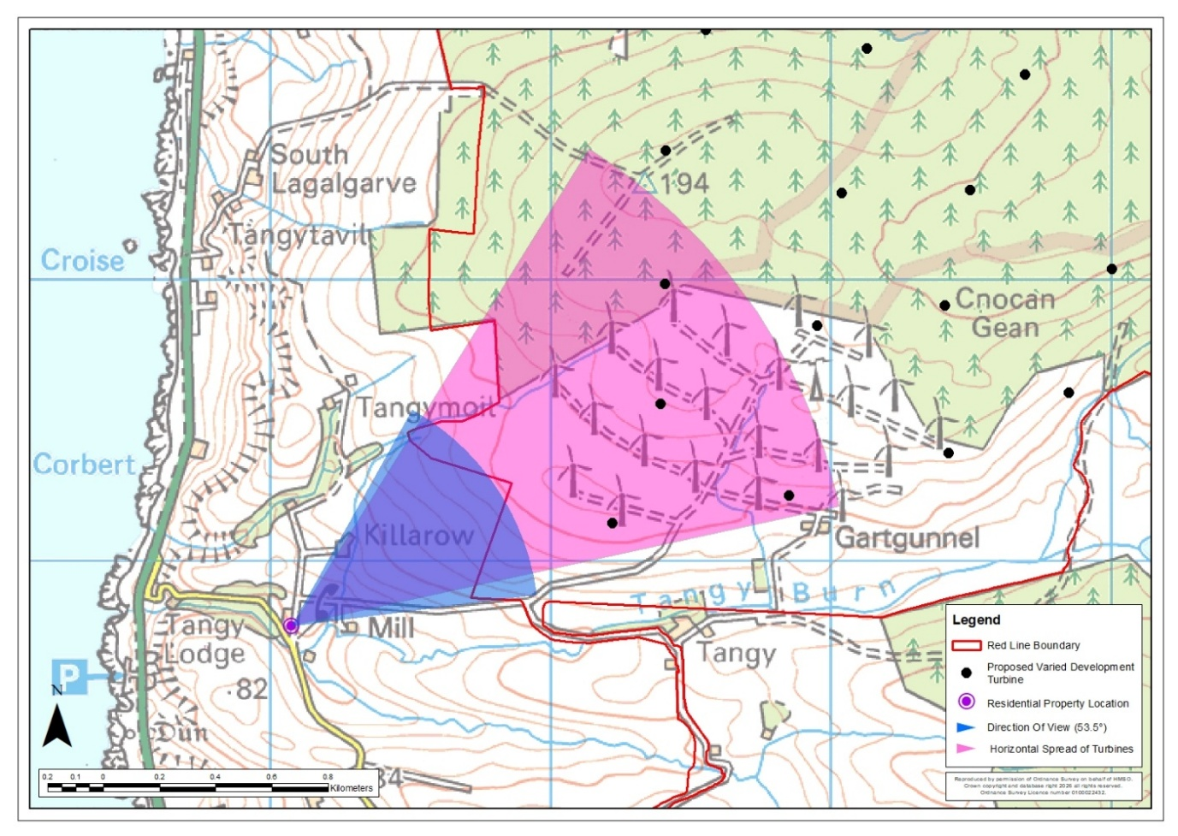
Killarow Cottage – Location Plan
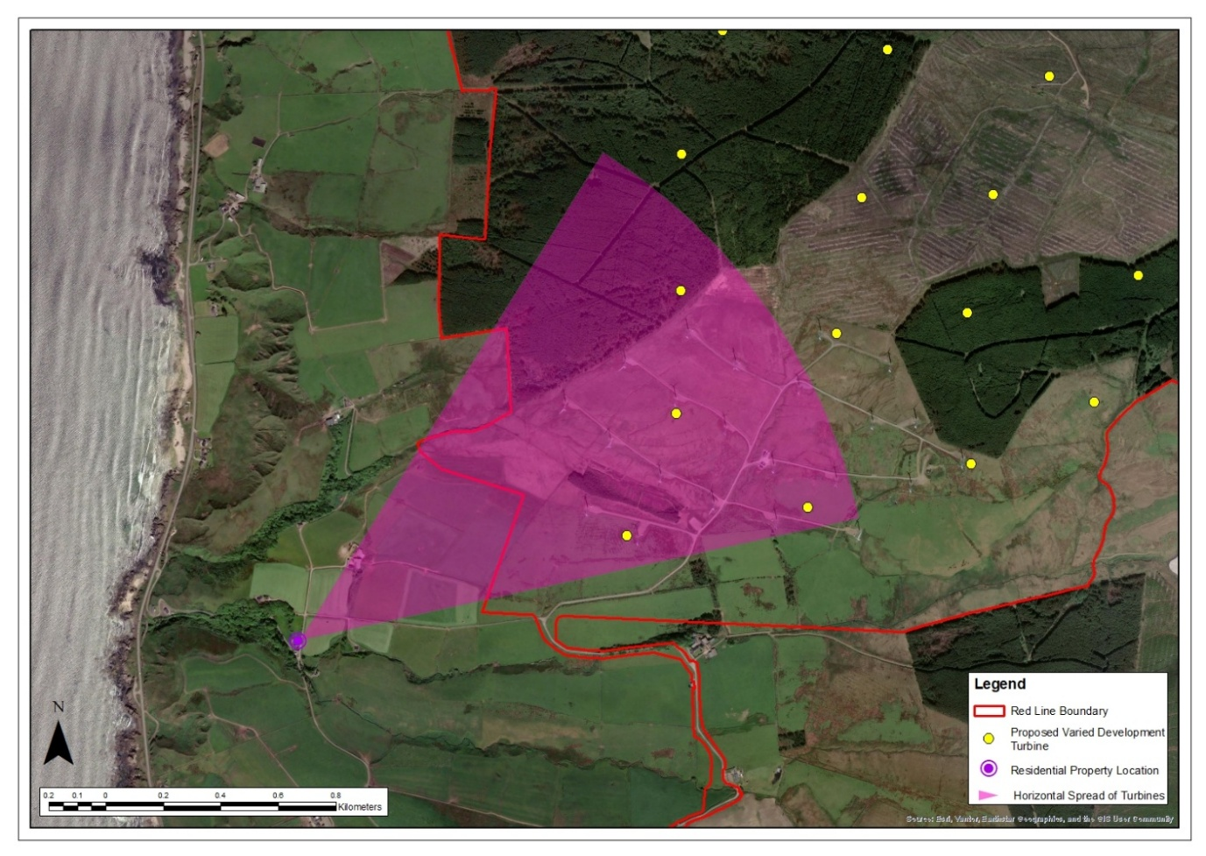
Killarow Cottage – Aerial Image

Table 9: Property No 9: 1 Tangy Cottage
Property No 9: 1 Tangy Cottage
Grid Reference: 166083 627762  Elevation: 50.6m |  | Distance to Nearest Visible Turbine: 1.19km  Blade Tips Theoretically Visible: 13  Hubs Theoretically Visible: 7
Property Description
☐ Detached  ☐ Semi-detached  ☒ Terraced  ☐ Farmhouse | ☒ 1 Storey  ☐ 2 Storey  ☐ Stone Built  ☒ Rendered | ☐ Farmyard  ☐ Outbuildings  ☐ Conservatory  ☐ Garages |  | ☒ Front Garden  ☒ Rear Garden  ☐ Side Garden
Description of Baseline Visual Amenity  This is a middle terrace property in a line of four terraced houses. Views from the front of the property and front garden are over the access road and agricultural land towards the Operational Development turbines which occupy the hill and skyline to the northeast. Views westward are over the rear garden onto mature deciduous trees that line Tangy Burn.  Nature of Change  The Proposed Varied Development turbines would be clearly visible in views from the front garden and the front of the property. They would replace the existing turbines in views to the northeast appearing noticeably larger. The aviation lights of two turbines would be theoretically visible during the hours of darkness.  Magnitude of Change: Medium - high  Significance of Effect: Significant |  |  | Residential Visual Amenity Threshold Assessment  The Proposed Varied Development turbines would be clearly visible from the front of the property replacing the Operational Development turbines. While they would be prominent, they would not introduce new features into views northeast and would not dominate the visual amenity of the property as rear views westward would remain unaffected. This is not considered to reach the RVAT.
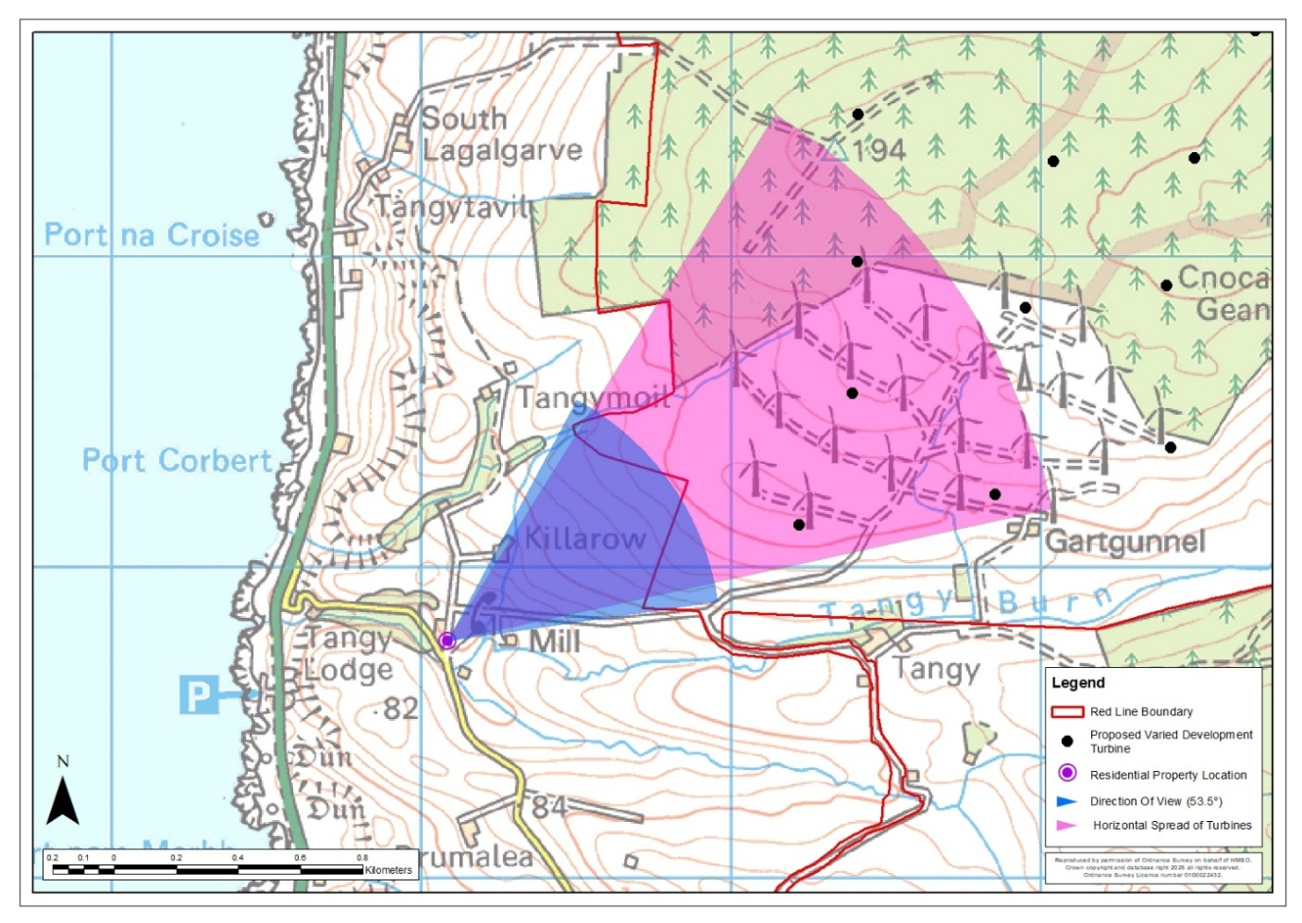
1 Tangy Cottage – Location Plan
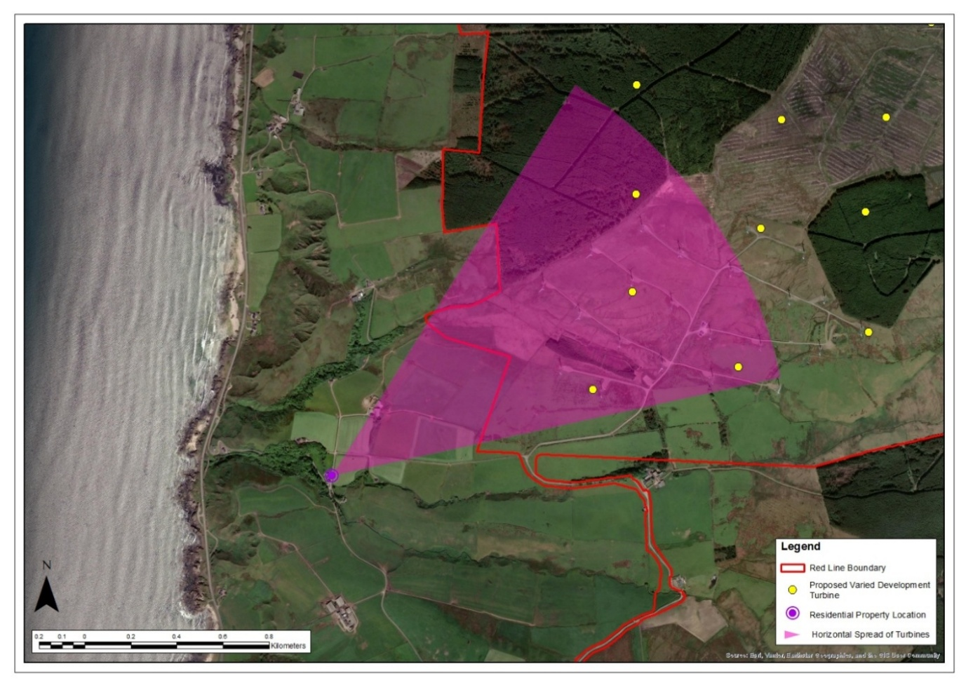
1 Tangy Cottage – Aerial Image

Table 10: Property No 10: Drumalea Farm Cottage
Property No 10: Drumalea Farm Cottage
Grid Reference: 166082 627751  Elevation: 49.5m |  | Distance to Nearest Visible Turbine: 1.20km  Blade Tips Theoretically Visible: 13  Hubs Theoretically Visible: 7
Property Description
☐ Detached  ☐ Semi-detached  ☒ Terraced  ☐ Farmhouse | ☒ 1 Storey  ☐ 2 Storey  ☐ Stone Built  ☒ Rendered | ☐ Farmyard  ☐ Outbuildings  ☐ Conservatory  ☐ Garages |  | ☒ Front Garden  ☒ Rear Garden  ☐ Side Garden
Description of Baseline Visual Amenity  This is a middle terrace property in a line of four terraced houses. Views from the front of the property and front garden are over the access road and agricultural land towards the Operational Development turbines which occupy the hill and skyline to the northeast. Views westward are over the rear garden onto mature deciduous trees that line Tangy Burn.  Nature of Change  The Proposed Varied Development turbines would be clearly visible in views from the front garden and the front of the property. They would replace the existing turbines in views to the northeast appearing noticeably larger. The aviation lights of two turbines would be theoretically visible during the hours of darkness.  Magnitude of Change: Medium - high  Significance of Effect: Significant |  |  | Residential Visual Amenity Threshold Assessment  The Proposed Varied Development turbines would be clearly visible from the front of the property replacing the Operational Development turbines. While they would be prominent, they would not introduce new features into views northeast and would not dominate the visual amenity of the property as rear views westward would remain unaffected. This is not considered to reach the RVAT.
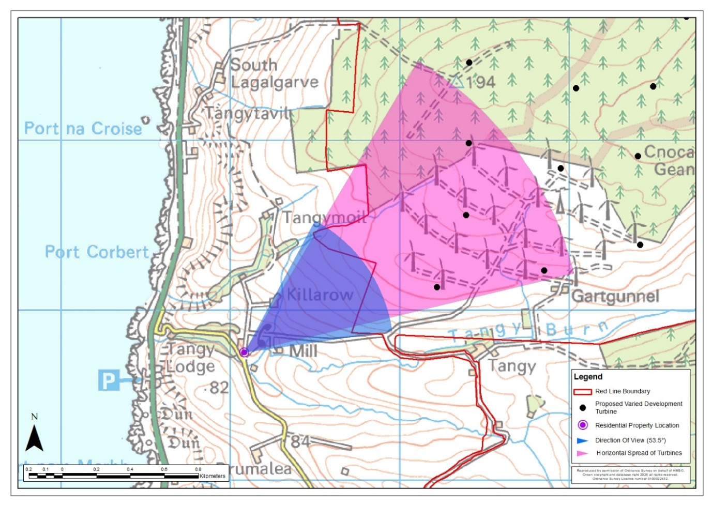
Drumalea Farm Cottage – Location Plan
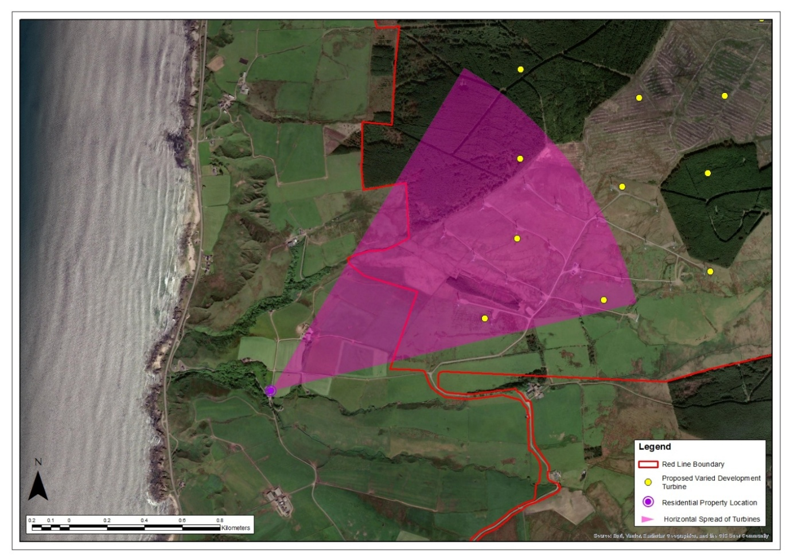
Drumalea Farm Cottage – Aerial Image

Table 11: Property No 11: Tangy Smithy
Property No 11: Tangy Smithy
Grid Reference: 166077 627732  Elevation: 47.2m |  | Distance to Nearest Visible Turbine: 1.21km  Blade Tips Theoretically Visible: 13  Hubs Theoretically Visible: 7
Property Description
☐ Detached  ☐ Semi-detached  ☒ Terraced  ☐ Farmhouse | ☒ 1 Storey  ☐ 2 Storey  ☒ Stone Built  ☐ Rendered | ☐ Farmyard  ☒ Outbuildings  ☐ Conservatory  ☐ Garages |  | ☒ Front Garden  ☒ Rear Garden  ☒ Side Garden
Description of Baseline Visual Amenity  This is an end terrace property at the most southernly point in the line of four terraced houses. Views from the front of the property and front garden are over the access road and agricultural land towards the Operational Development turbines which occupy the hill and skyline to the northeast. Views westward are over the rear garden onto mature deciduous trees that line Tangy Burn. Views from the side garden and allotment are generally oriented southward and contained by hedgerow and mature trees, although there would be some oblique views of the Operational Development to the northeast.  Nature of Change  The Proposed Varied Development turbines would be clearly visible in views from the front garden and the front of the property. They would replace the existing turbines in views to the northeast appearing noticeably larger. The aviation lights of two turbines would be theoretically visible during the hours of darkness.  Magnitude of Change: Medium - high  Significance of Effect: Significant |  |  | Residential Visual Amenity Threshold Assessment  The Proposed Varied Development turbines would be clearly visible from the front of the property replacing the Operational Development turbines. While they would be prominent, they would not introduce new features into views northeast and would not dominate the visual amenity of the property as rear views westward and views south from the side garden would remain unaffected. This is not considered to reach the RVAT.
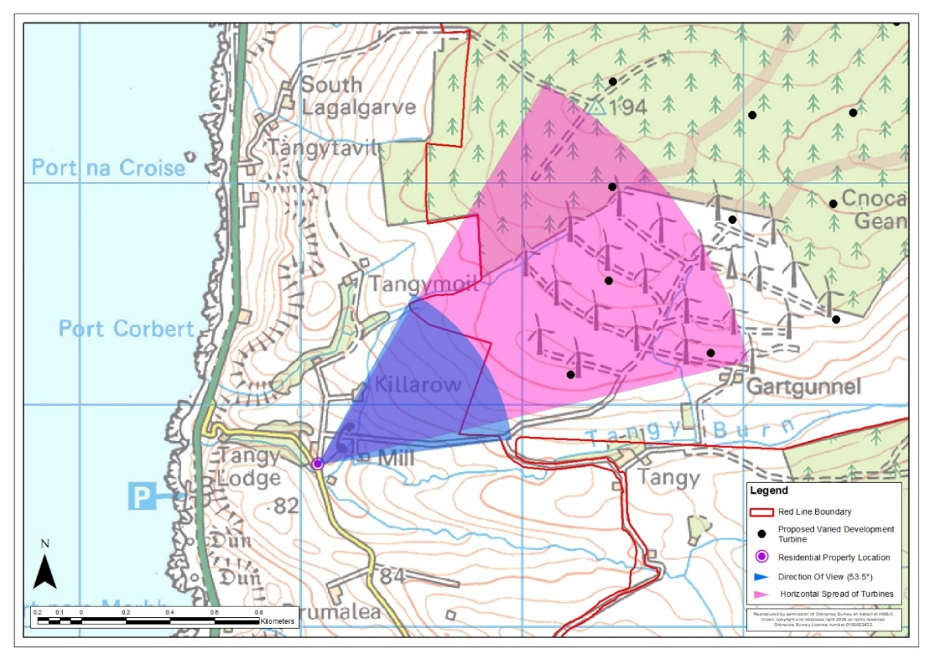
Tangy Smithy – Location Plan
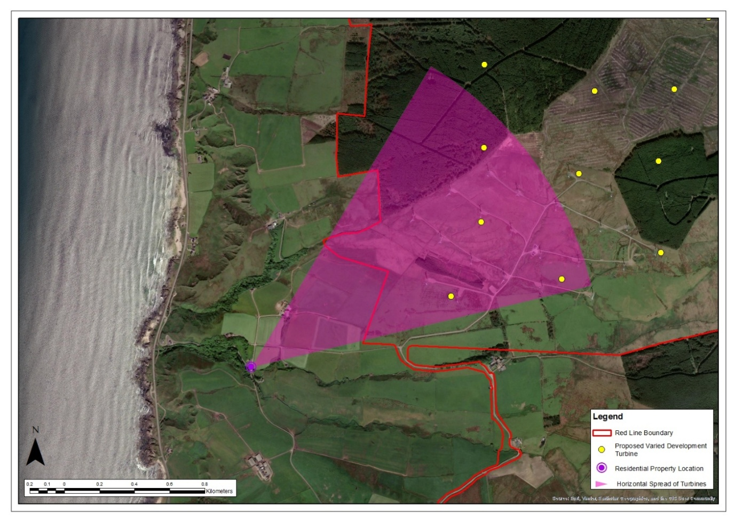
Tangy Smithy – Aerial Image

Table 12: Property No 12: Tangy Mill
Property No 12: Tangy Mill
Grid Reference: 166276 627750  Elevation: 55.8m |  | Distance to Nearest Visible Turbine: 1.02km  Blade Tips Theoretically Visible: 8  Hubs Theoretically Visible: 3
Property Description
☒ Detached  ☐ Semi-detached  ☐ Terraced  ☐ Farmhouse | ☐ 2 Storey  ☒ 3 Storey  ☐ Stone Built  ☒ Rendered | ☐ Farmyard  ☐ Outbuildings  ☐ Conservatory  ☐ Garages |  | ☒ Front Garden  ☒ Rear Garden  ☐ Side Garden
Description of Baseline Visual Amenity  This is a holiday let in a converted mill set within agricultural land. It is positioned at a slightly lower elevation so that the mill could be powered by Tangy Burn. The majority of windows are positioned looking south and west over Tangy Burn. Some of the Operational Development turbines are visible from the front of the property and parking area against the skyline to the northeast over an intervening knoll and agricultural land. Rear views are over agricultural land and Tangy Burn.  Nature of Change  The Proposed Varied Development turbines would be clearly visible in views from the front garden and the front of the property. They would replace the existing turbines in these views appearing noticeably larger. The aviation lights of one turbine would be theoretically visible during the hours of darkness.  Magnitude of Change: Medium - high  Significance of Effect: Significant |  |  | Residential Visual Amenity Threshold Assessment  The Proposed Varied Development turbines would be clearly visible from the front of the property and parking area. However, they would not affect views south and west from windows overlooking the burn. They would be seen in a similar part of the view as the Operational Development turbines which they would replace. While this would represent a significant effect, it is not considered to reach the RVAT. The turbines would be prominent but would not introduce new features into views northeast and would not dominate the visual amenity of the property, given that valued views south and west would not be affected.
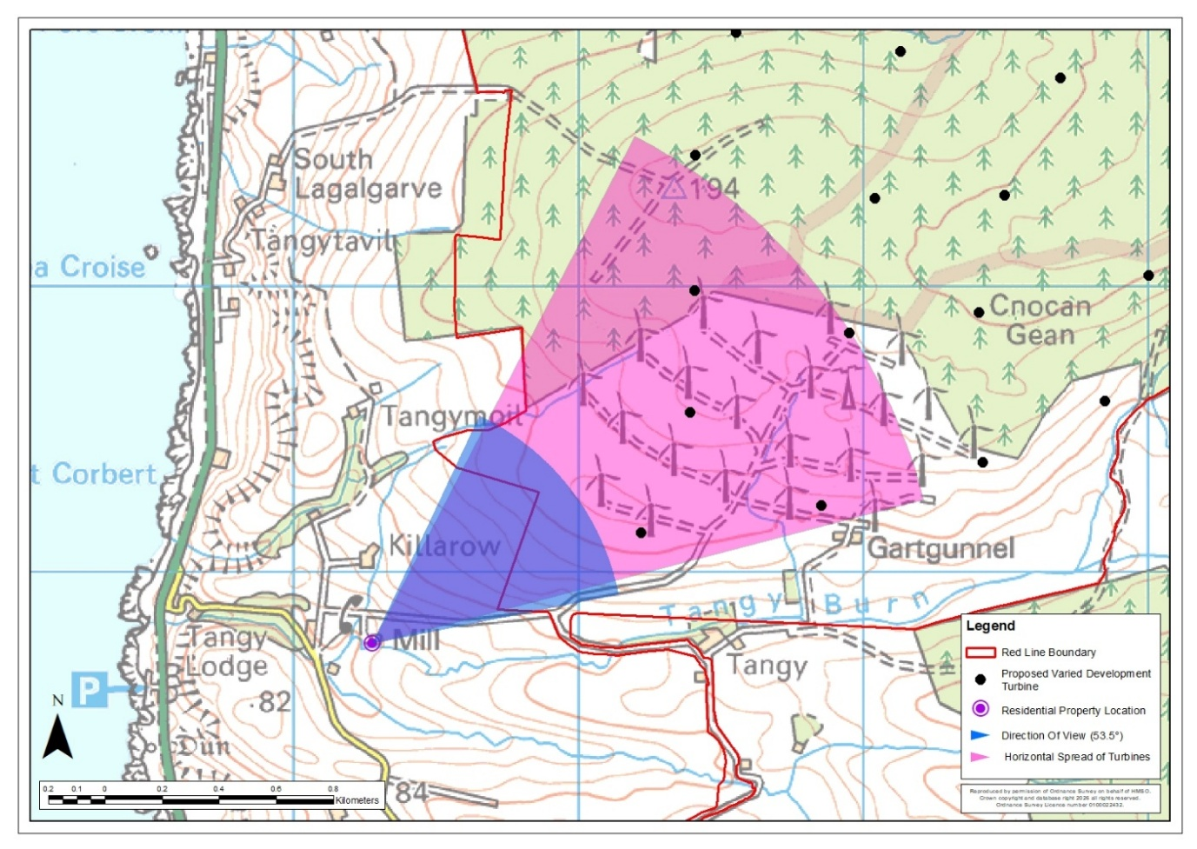
Tangy Mill – Location Plan
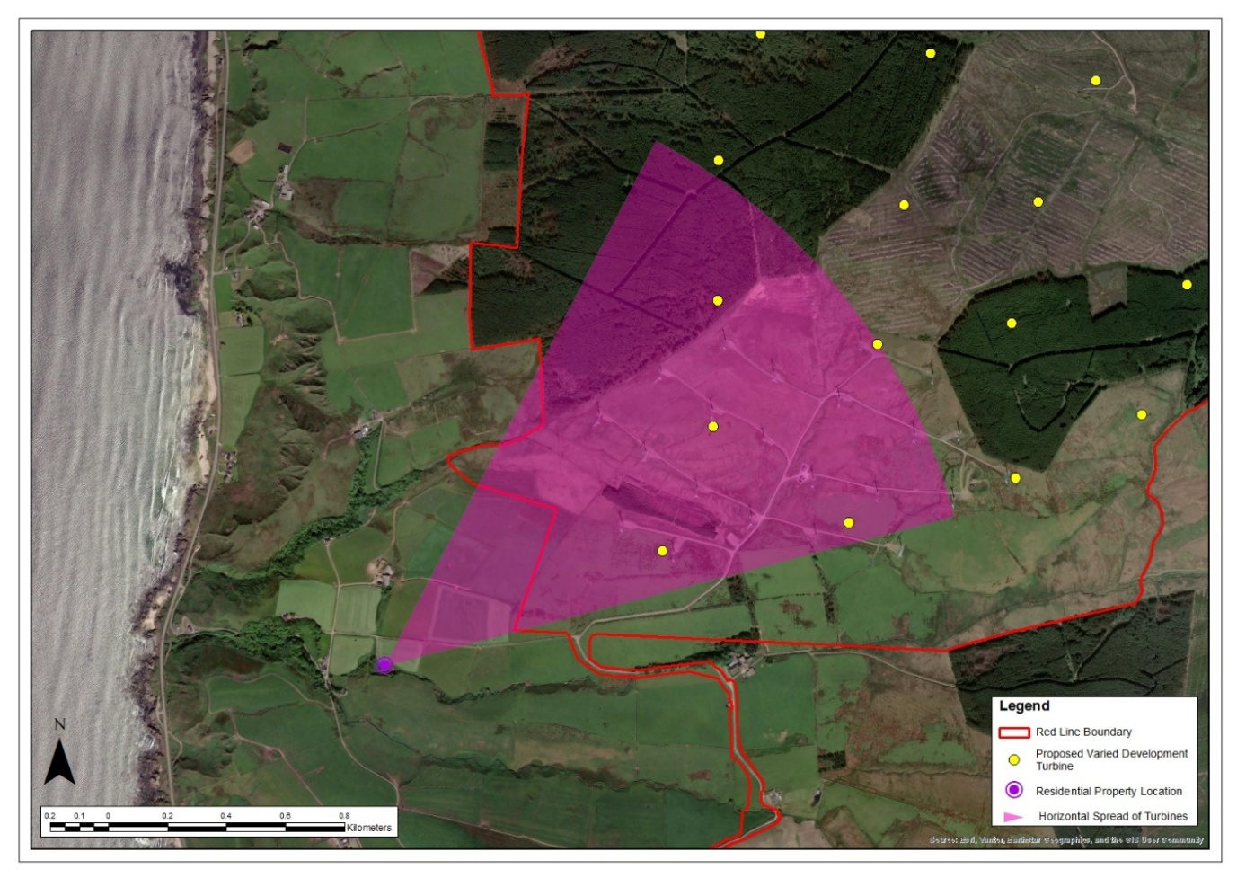
Tangy Mill – Aerial Image

Table 13: Property No 13: Tangy Mill Croft
Property No 13: Tangy Mill Croft
Grid Reference: 166134 627657  Elevation: 45.3m |  | Distance to Nearest Visible Turbine: 1.18km  Blade Tips Theoretically Visible: 12  Hubs Theoretically Visible: 7
Property Description
☒ Detached  ☐ Semi-detached  ☐ Terraced  ☐ Farmhouse | ☐ 1 Storey  ☒ 2 Storey  ☐ Stone Built  ☒ Rendered | ☐ Farmyard  ☒ Outbuildings  ☐ Conservatory  ☐ Garages |  | ☒ Front Garden  ☒ Rear Garden  ☒ Side Garden
Description of Baseline Visual Amenity  Views south and west are over the garden and burn. More distant views to the south and west are somewhat contained by rising landform and vegetation. The front of the property, front garden, side garden face northeast views over fields towards Tangy Mill and the Operational Development turbines somewhat filtered by existing garden vegetation. Mature trees filter views north and north-westward.  Nature of Change  The Proposed Varied Development turbines would be visible in views from the front garden and the front of the property. They would replace the existing turbines in these views appearing noticeably larger. The aviation lights of two turbines would be theoretically visible during the hours of darkness.  Magnitude of Change: Medium - high  Significance of Effect: Significant |  |  | Residential Visual Amenity Threshold Assessment  The Proposed Varied Development turbines would be visible from the front of the property replacing the Operational Development turbines. Intervening garden vegetation may provide some filtering of views from the dwelling itself, however turbines would be clearly visible from parts of the garden. The Proposed Varied Development would not affect views south and west overlooking the burn. The turbines would be prominent but would not introduce new features into views northeast and would not dominate the visual amenity of the property. This is not considered to reach the RVAT.
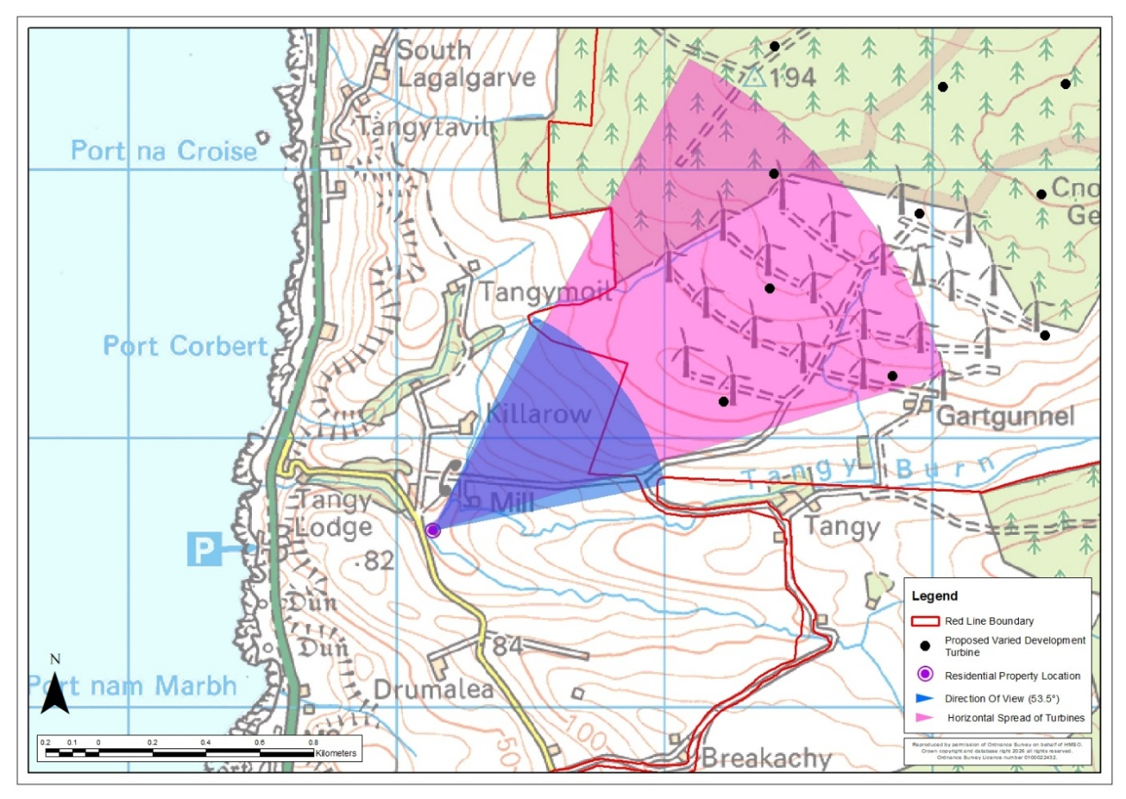
Tangy Mill Croft – Location Plan
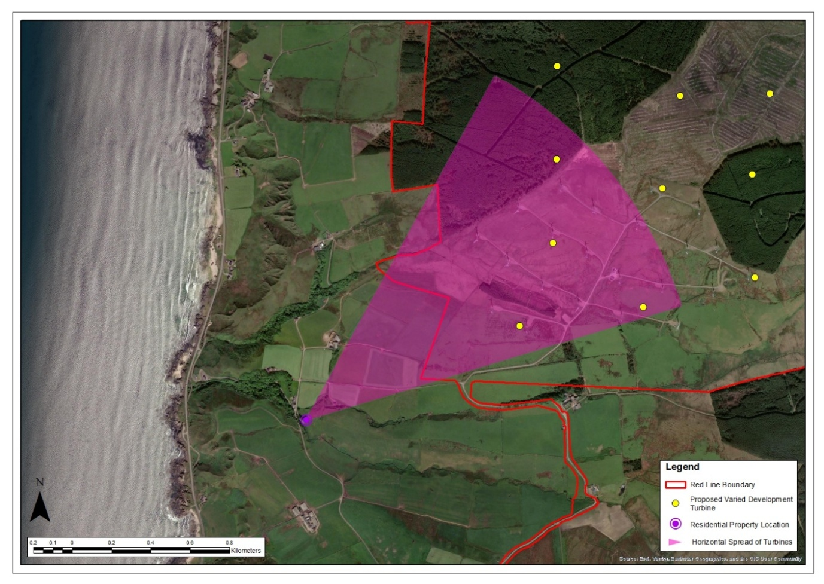
Tangy Mill Croft – Aerial Image

Table 14: Property No 14: Tangy Farm
Property No 14: Tangy Farm
Grid Reference: 167436 627737  Elevation: 114.7m |  | Distance to Nearest Visible Turbine: 0.45km  Blade Tips Theoretically Visible: 16  Hubs Theoretically Visible: 14
Property Description
☒ Detached  ☐ Semi-detached  ☐ Terraced  ☒ Farmhouse | ☐ 1 Storey  ☒ 2 Storey  ☒ Stone Built  ☐ Rendered | ☒ Farmyard  ☒ Outbuildings  ☐ Conservatory  ☐ Garages |  | ☒ Front Garden  ☐ Rear Garden  ☒ Side Garden
Description of Baseline Visual Amenity  Main views from this property are westward towards the sea, with the farmhouse orientated in this direction. Side views from the farmyard and the north rear facing side of the farmhouse look directly at the Operational Development, although a buffer of large, mature deciduous trees and conifer hedging provide considerable screening. The north edge of the property as a whole is contained by trees.  Nature of Change  The Proposed Varied Development turbines would be visible in views northward. Although existing mature vegetation would provide some screening and filtering, the turbines would occasionally be visible above this, similar to the Operational Development turbines but noticeably larger. The aviation lights of four turbines would be theoretically visible during the hours of darkness.  Magnitude of Change: Medium  Significance of Effect: Significant |  |  | Residential Visual Amenity Threshold Assessment  The outbuildings within the farmyard offer some level of screening for views northward from within the farmhouse. Despite the extensive screening around the property, the Proposed Varied Development turbines would clearly feature in north and eastern views from this property due to their close proximity. Valued seaward views, which the farmyard is oriented towards would not be affected. While they would be prominent, they would not introduce new features into views north and east and would not dominate the visual amenity of the property. This is not considered to reach the RVAT.
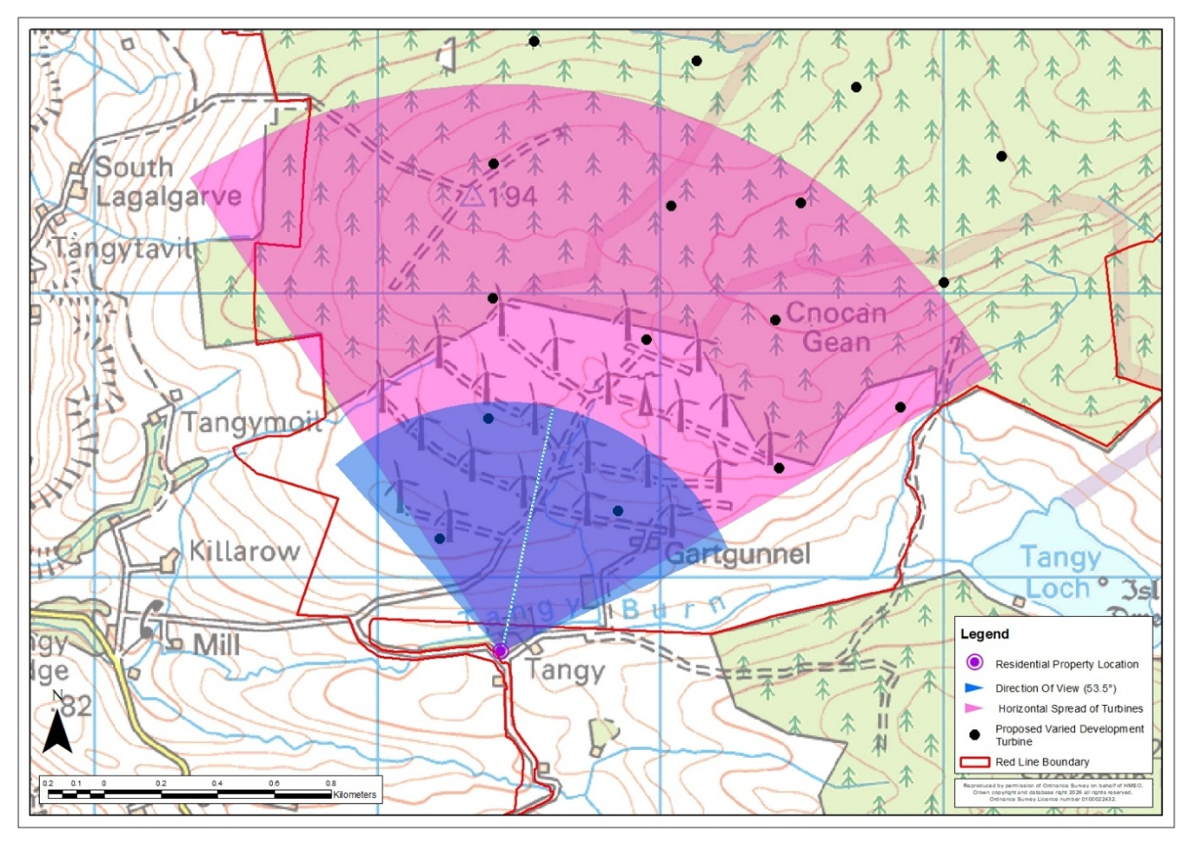
Tangy Farm – Location Plan
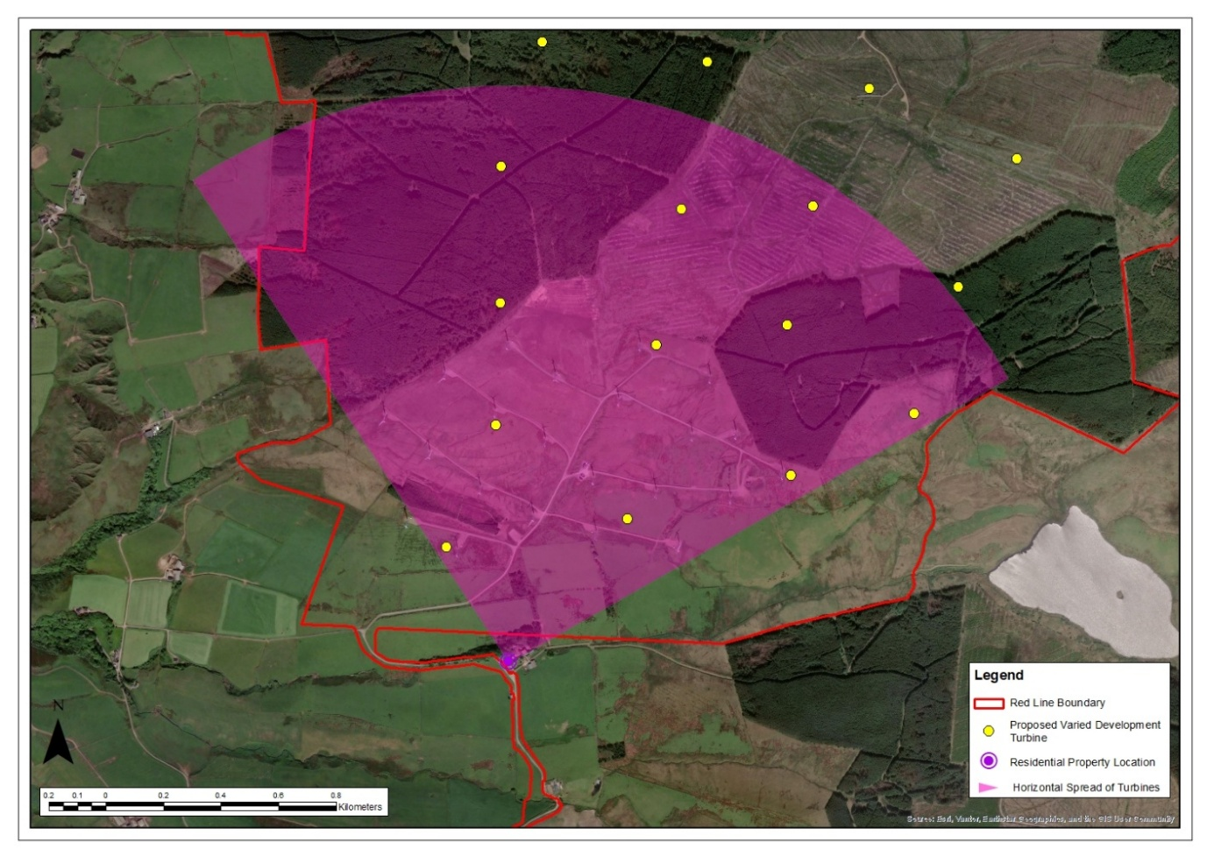
Tangy Farm – Aerial Image

Table 15: Property No 15: Tangy Lea Cottage
Property No 15: Tangy Lea Cottage
Grid Reference: 167458 627625  Elevation: 114.9m |  | Distance to Nearest Visible Turbine: 0.56km  Blade Tips Theoretically Visible: 16  Hubs Theoretically Visible: 16
Property Description
☒ Detached  ☐ Semi-detached  ☐ Terraced  ☐ Farmhouse | ☒ 1 Storey  ☐ 2 Storey  ☐ Stone Built  ☒ Rendered | ☒ Farmyard  ☒ Outbuildings  ☐ Conservatory  ☐ Garages |  | ☒ Front Garden  ☒ Rear Garden  ☒ Side Garden
Description of Baseline Visual Amenity  Views from the front of this property and garden are across undulating agricultural land with the Operational Development a clear feature in views. Conifer plantations feature within views against the skyline beyond the Operational Development, while the rooftops of the Tangy Farm outbuildings are visible within the lower levels of the undulations in the midground. Rear views are westward towards the sea over agricultural fields.  Nature of Change  The Proposed Varied Development turbines would appear prominent in views from the front garden and the front of the property. They would replace the existing turbines in views to the north appearing noticeably larger. The aviation lights of five turbines would be theoretically visible during the hours of darkness.  Magnitude of Change: High  Significance of Effect: Significant |  |  | Residential Visual Amenity Threshold Assessment  The Proposed Varied Development turbines would be considerably larger than the existing turbines and experienced in close proximity. They would increase the prominence of turbines within views north due to their increase in size. While they would be prominent in views from the front and side of the property, they would not introduce new features into these views. They would also not affect rear seaward views. It is therefore considered that while there would be a significant effect, they would not dominate the visual amenity of the property such that they would lead to an overbearing or overwhelming effect that would render the property an unattractive place in which to live. This is not considered to reach the RVAT.
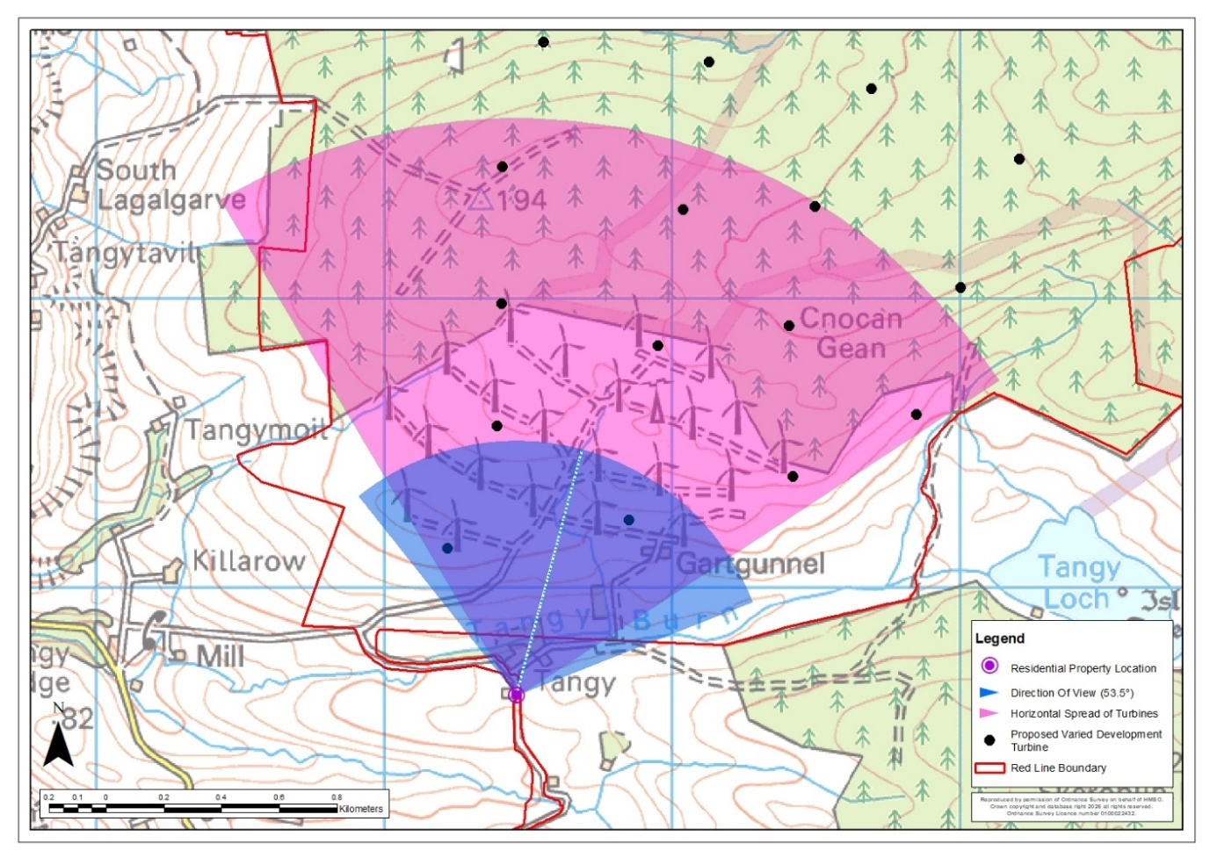
Tangy Lea Cottage – Location Plan
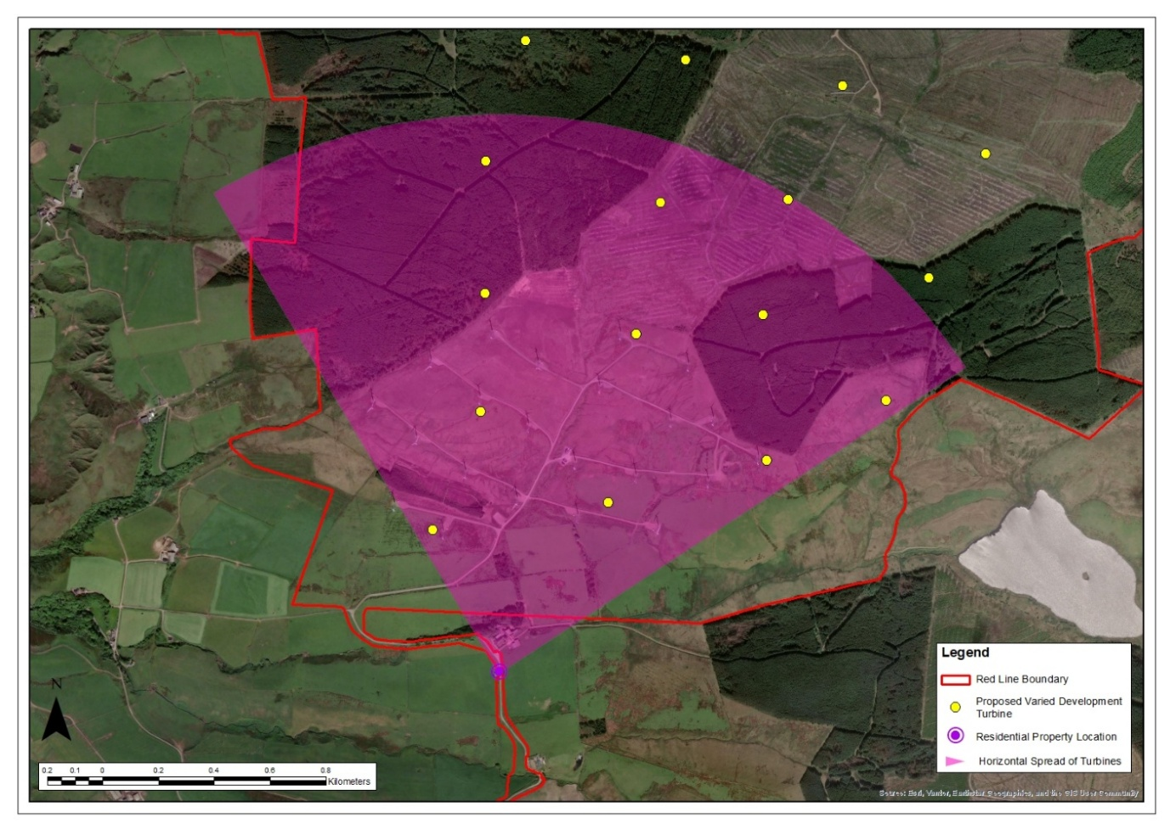
Tangy Lea Cottage – Aerial Image

Table 16: Property No 16: Drumalea Farm
Property No 16: Drumalea Farm
Grid Reference: 166133 627124  Elevation: 63.9m |  | Distance to Nearest Visible Turbine: 1.48km  Blade Tips Theoretically Visible: 15  Hubs Theoretically Visible: 7
Property Description
☒ Detached  ☐ Semi-detached  ☐ Terraced  ☒ Farmhouse | ☐ 1 Storey  ☒ 2 Storey  ☐ Stone Built  ☒ Rendered | ☒ Farmyard  ☒ Outbuildings  ☐ Conservatory  ☐ Garages |  | ☐ Front Garden  ☐ Rear Garden  ☐ Side Garden
Description of Baseline Visual Amenity  This property is a large working dairy farm that occupies a lower elevation than the minor road that serves it. Views from the farmhouse are westwards towards the sea. Views eastward are contained by farm outbuildings and rising landform. There is no visibility of the Operational Development due to screening from barns and outbuildings. From the farm track and outbuildings, views north-eastward are across agricultural land and contained by a hill with limited long-distance views.  Nature of Change  There would be no view of the Proposed Varied Development from the dwelling itself due to screening by outbuildings and rising landform. The Proposed Varied Development would be clearly visible in views to the north-east from the farm track that serves the property appearing larger than the Operational Development turbines. The aviation light of one turbine would be theoretically visible during the hours of darkness.  Magnitude of Change: Low - medium  Significance of Effect: Not Significant |  |  | Residential Visual Amenity Threshold Assessment  The Proposed Varied Development turbines would not affect views from the dwelling itself including the main views west towards the sea. They would largely be screened in views east by farm outbuildings and rising landform, although they would be visible from the farm track which provides access to the property. This is not considered to reach the RVAT.
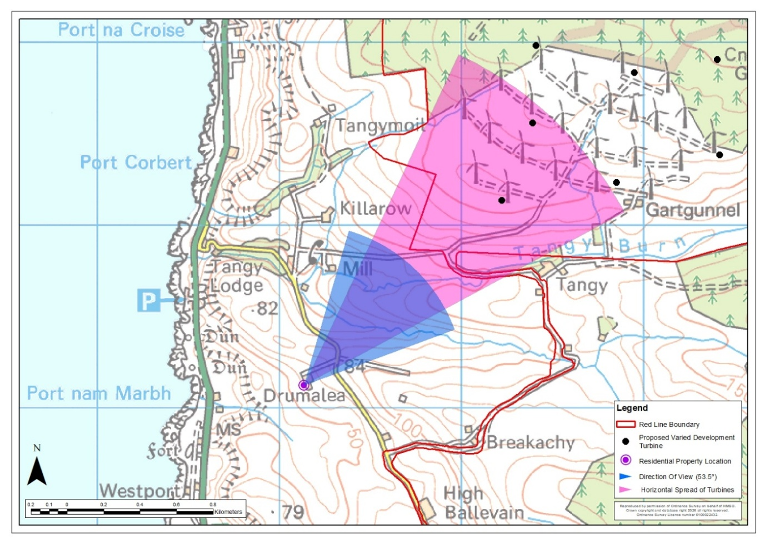
Drumalea Farm – Location Plan
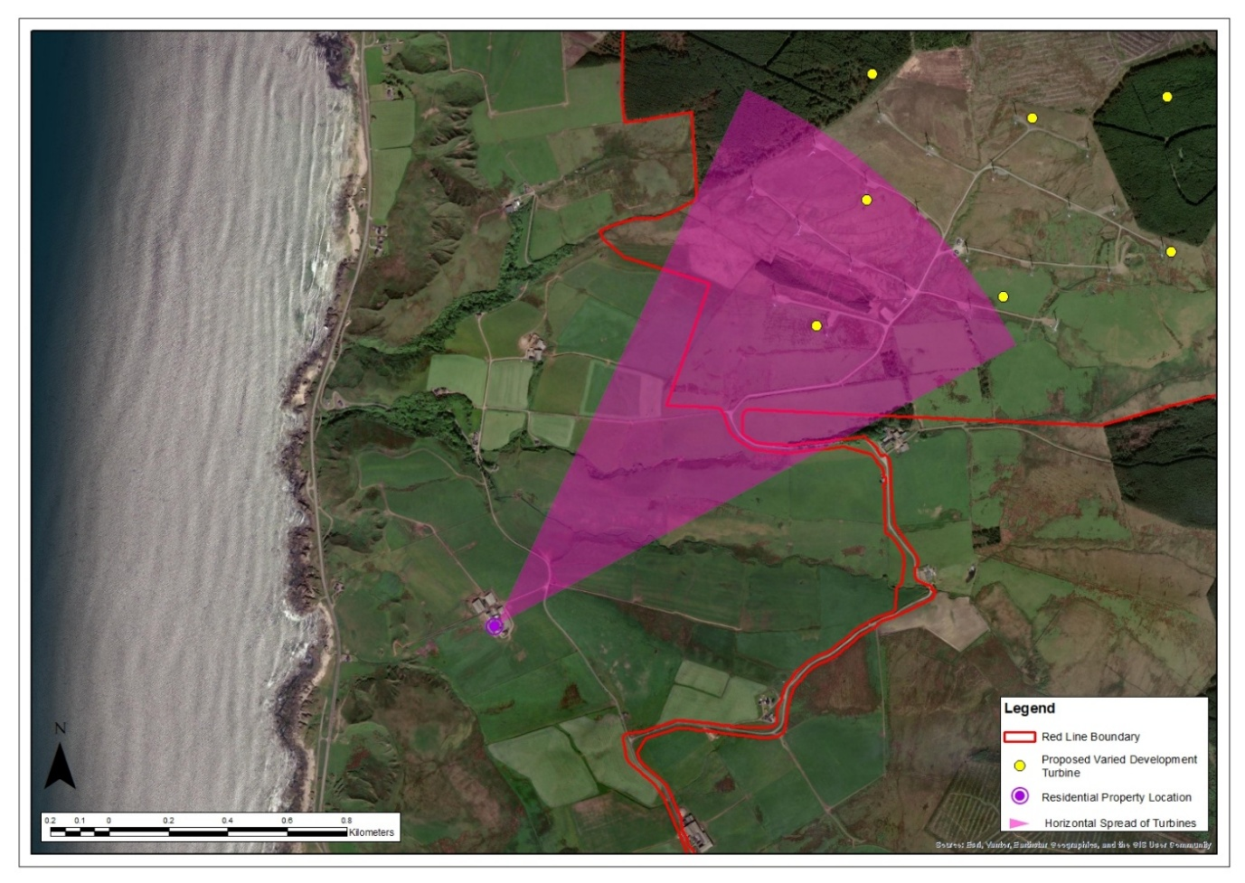
Drumalea Farm – Aerial Image

Table 17: Property No 17: Dalnaspidal / Hazel’s Cottage
Property No 17: Dalnaspidal / Hazel’s Cottage
Grid Reference: 167592 627315  Elevation: 108.3m |  | Distance to Nearest Visible Turbine: 0.90km  Blade Tips Theoretically Visible: 16  Hubs Theoretically Visible: 16
Property Description
☐ Detached  ☒ Semi-detached  ☐ Terraced  ☐ Farmhouse | ☒ 1 Storey  ☐ 2 Storey  ☐ Stone Built  ☒ Rendered | ☐ Farmyard  ☒ Outbuildings  ☐ Conservatory  ☐ Garages |  | ☒ Front Garden  ☒ Rear Garden  ☒ Side Garden
Description of Baseline Visual Amenity  Views from the front of this property are westwards over agricultural land with the sea in the distance. The Operational Development appears in side views from the front of the property. From the rear of the property and rear garden, the Operational Development dominates the skyline to the north with pockets of conifer trees in the midground. An outbuilding and storage area occupy part of the view across the rear yard.  Nature of Change  The Proposed Varied Development turbines would appear prominent in side views from the front garden and from the rear of the property. They would replace the Operational Development turbines in views to the north appearing noticeably larger. Views west towards the sea and south from the side garden would be unaffected. The aviation lights of five turbines would be theoretically visible during the hours of darkness.  Magnitude of Change: High  Significance of Effect: Significant |  |  | Residential Visual Amenity Threshold Assessment  The Proposed Varied Development turbines would be considerably larger than the existing turbines and experienced in close proximity. They would increase the prominence of turbines within views north from the front and rear gardens due to their increased size. While they would be prominent in these views, they would not introduce new features into the view. Westward views from the front windows of the property and south from the side garden would remain unaffected. While the turbines would not dominate or overwhelm views in all directions, they would appear very close and dominant in side views from the rear of the property across the rear garden and car parking area leading to a significant effect. The turbines would not dominate or overwhelm views in all directions, however they would appear unpleasantly close and dominant in rear views. This has the potential to give rise to the RVAT being reached.
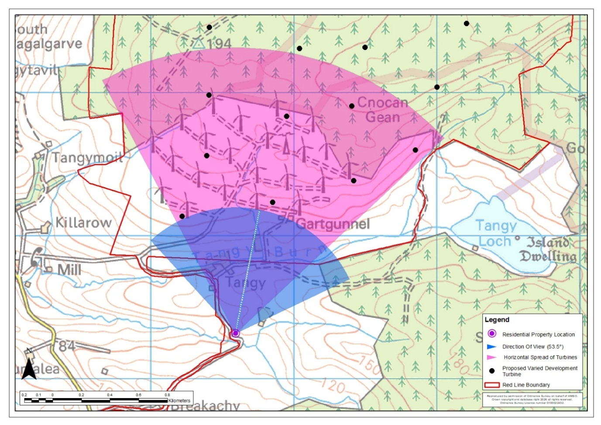
Dalnaspidal / Hazel’s Cottage – Location Plan
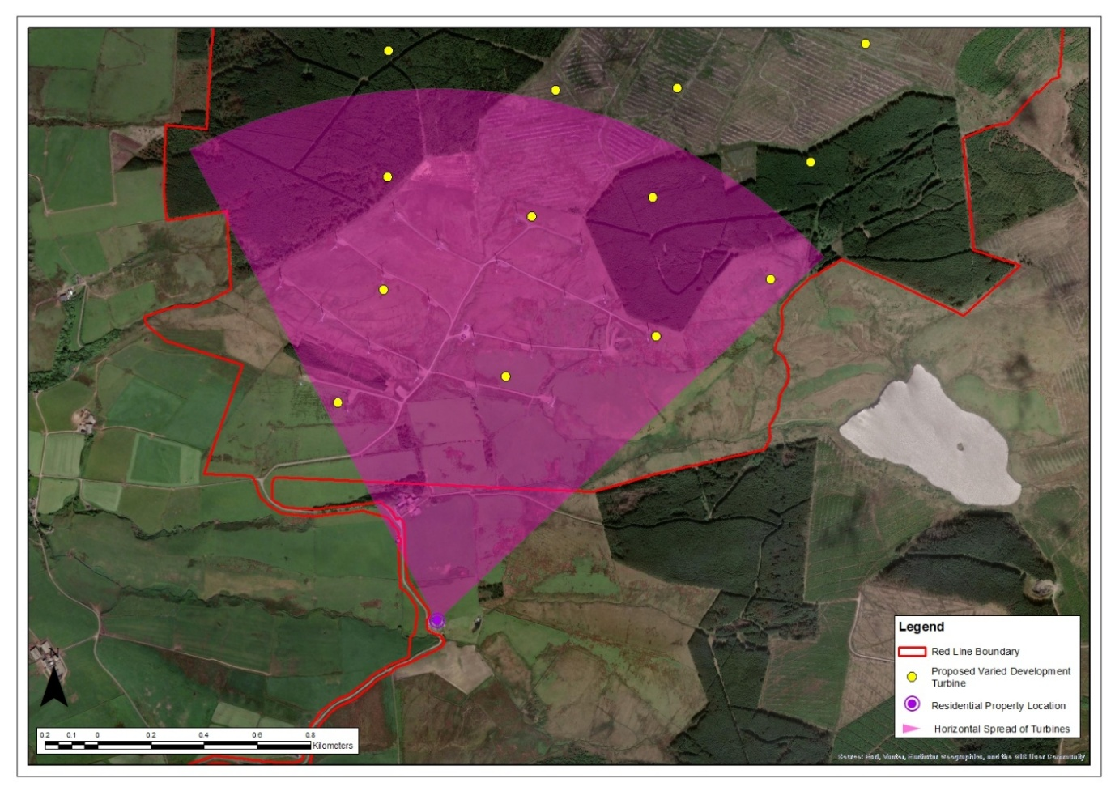
Dalnaspidal / Hazel’s Cottage – Aerial Image

Table 18: Property No 18: Breakachy (Number 4)
Property No 19: Breakachy (Number 4)
Grid Reference: 167033 626861  Elevation: 128.1m |  | Distance to Nearest Visible Turbine: 1.28km  Blade Tips Theoretically Visible: 16  Hubs Theoretically Visible: 16
Property Description
☒ Detached  ☐ Semi-detached  ☐ Terraced  ☐ Farmhouse | ☒ 1 Storey  ☐ 2 Storey  ☐ Stone Built  ☐ Rendered | ☐ Farmyard  ☒ Outbuildings  ☐ Conservatory  ☐ Garages |  | ☒ Front Garden  ☒ Rear Garden  ☐ Side Garden
Description of Baseline Visual Amenity  Main views from this property are expansive and orientated south and south-westward towards the sea and over Aros Moss. Views from the rear garden are orientated northward with clear views towards the Operational Development across undulating agricultural land with conifer planting. An existing outbuilding and a caravan in the rear garden provide a small degree of screening from rear windows of the property.  Nature of Change  The Proposed Varied Development turbines would be visible in rear views to the north. They would replace the existing turbines appearing noticeably larger. The aviation lights of five turbines would be theoretically visible during the hours of darkness.  Magnitude of Change: Medium - high  Significance of Effect: Significant |  |  | Residential Visual Amenity Threshold Assessment  The Proposed Varied Development turbines would not affect the property’s valued views to the west towards the sea or south over Aros Moss. The turbines would feature clearly in rear views northward although an existing outbuilding may offer some screening. They would be seen in a similar part of the view as the Operational Development turbines which they would replace but appear noticeably larger. The turbines would be prominent but would not introduce new features into views northward and would not dominate the visual amenity of the property, given that valued seaward views would not be affected. This is not considered to reach the RVAT.
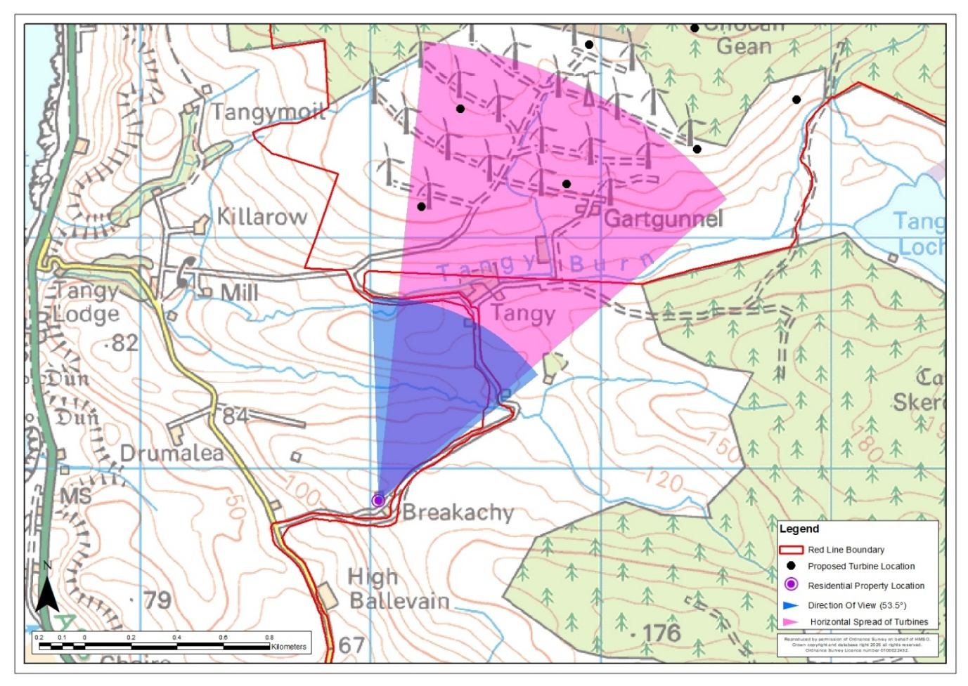
Breakachy (Number 4) – Location Plan
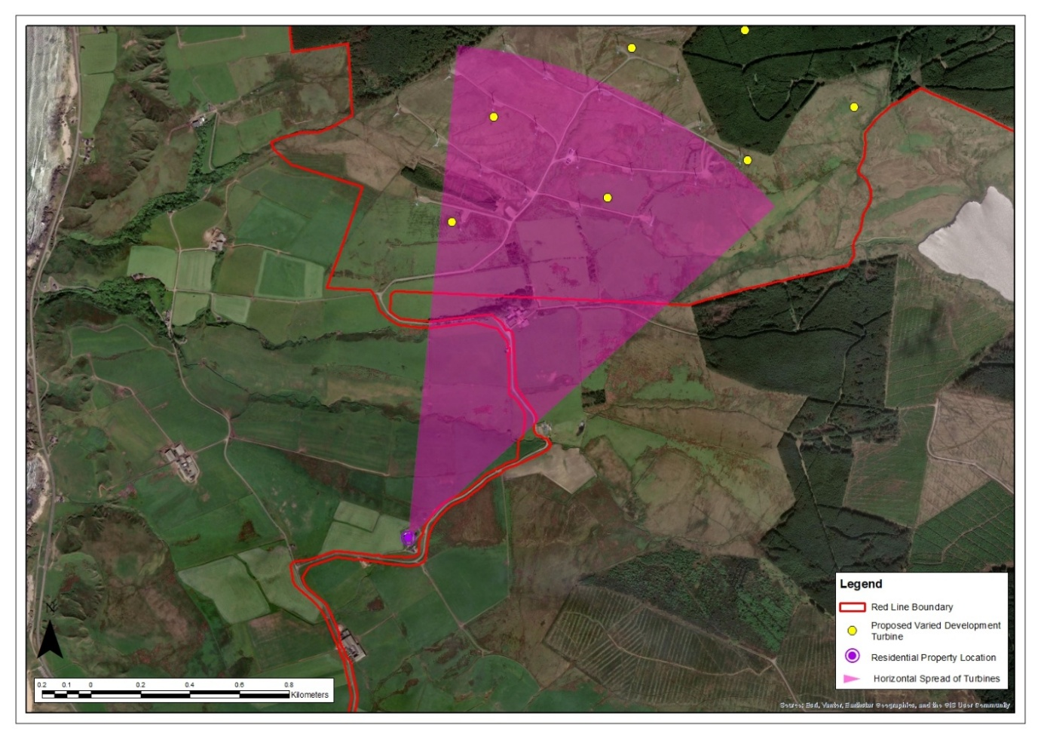
Breakachy (Number 4) – Aerial Image

Table 19: Property No 19: Breakachy House
Property No 20: Breakachy House
Grid Reference: 167071 626815  Elevation: 123.3m |  | Distance to Nearest Visible Turbine: 1.32km  Blade Tips Theoretically Visible: 16  Hubs Theoretically Visible: 15
Property Description
☒ Detached  ☐ Semi-detached  ☐ Terraced  ☐ Farmhouse | ☐ 1 Storey  ☒ 2 Storey  ☐ Stone Built  ☒ Rendered | ☐ Farmyard  ☐ Outbuildings  ☐ Conservatory  ☐ Garages |  | ☒ Front Garden  ☒ Rear Garden  ☐ Side Garden
Description of Baseline Visual Amenity  Main views from this property are orientated south and south-westwards with expansive sea views. The property is somewhat nestled into a slope and situated at a lower elevation than neighbouring properties which offers a degree of screening to the north towards the Operational Development turbines.  Nature of Change  The Proposed Varied Development turbines would appear in side views to the north against the sky. Due to the orientation of the windows, views from within the property are likely to be more limited. The aviation lights of four turbines would be theoretically visible during the hours of darkness.  Magnitude of Change: Medium  Significance of Effect: Significant |  |  | Residential Visual Amenity Threshold Assessment  The Proposed Varied Development turbines would not affect the property’s valued views to the west towards the sea. The turbines would feature clearly in views northward but would not dominate the visual amenity of the property, given that valued seaward views would not be affected. This is not considered to reach the RVAT.
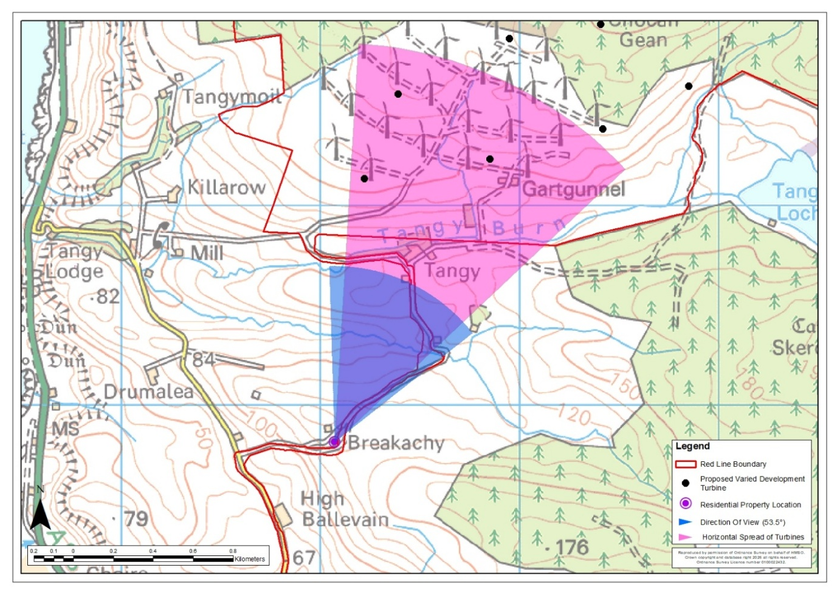
Breakachy House – Location Plan
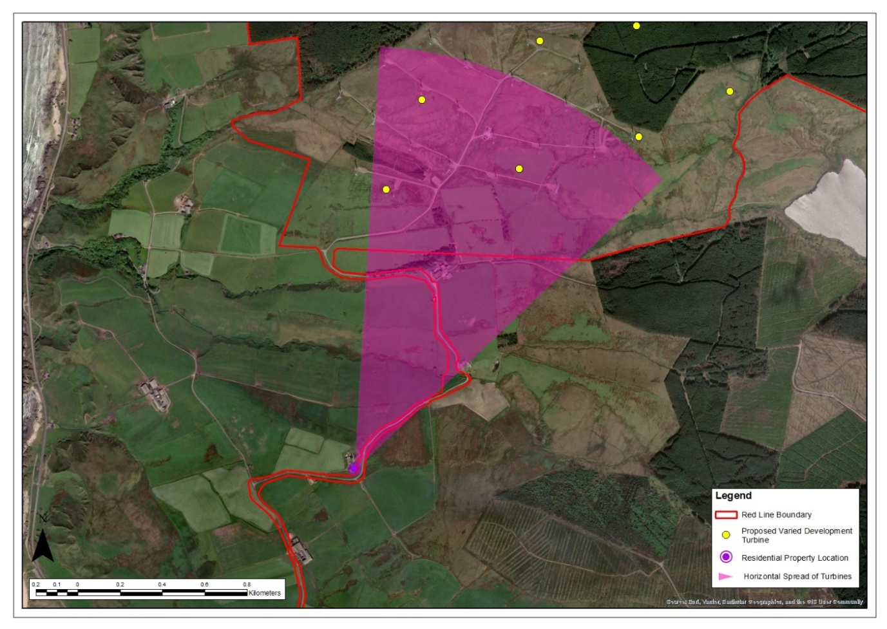
Breakachy House – Aerial Image

Table 20: Property No 20: Breakachy (Number 5)
Property No 21: Breakachy (Number 5)
Grid Reference: 167044 626859  Elevation: 128.0m |  | Distance to Nearest Visible Turbine: 1.28km  Blade Tips Theoretically Visible: 16  Hubs Theoretically Visible: 16
Property Description
☐ Detached  ☒ Semi-detached  ☐ Terraced  ☐ Farmhouse | ☒ 1 Storey  ☐ 2 Storey  ☐ Stone Built  ☒ Rendered | ☐ Farmyard  ☐ Outbuildings  ☐ Conservatory  ☐ Garages |  | ☒ Front Garden  ☒ Rear Garden  ☐ Side Garden
Description of Baseline Visual Amenity  Main views from this property are expansive and orientated south and south-westward towards the sea and over Aros Moss and Campbeltown Airport. Views from the rear garden are orientated northward with clear views towards the Operational Development across undulating agricultural land with conifer planting.  Nature of Change  The Proposed Varied Development turbines would be clearly visible in rear views to the north. They would replace the existing turbines appearing noticeably larger. The aviation lights of five turbines would be theoretically visible during the hours of darkness.  Magnitude of Change: Medium - high  Significance of Effect: Significant |  |  | Residential Visual Amenity Threshold Assessment  The Proposed Varied Development turbines would not affect the property’s valued views to the west towards the sea or south over Aros Moss. The turbines would feature prominently in rear views northward. They would be seen in a similar part of the view as the Operational Development turbines which they would replace but appear noticeably larger. The turbines would be prominent but would not introduce new features into views northward and would not dominate the visual amenity of the property, given that valued seaward views would not be affected. This is not considered to reach the RVAT.
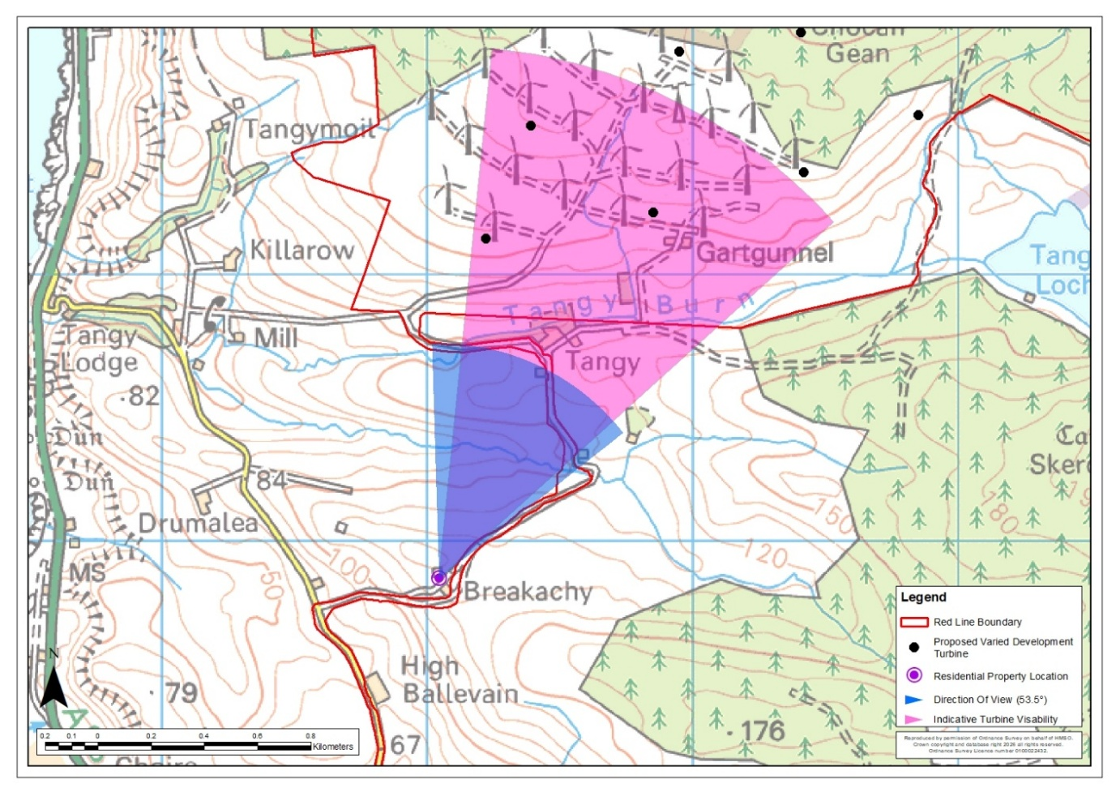
Breakachy (Number 5) – Location Plan
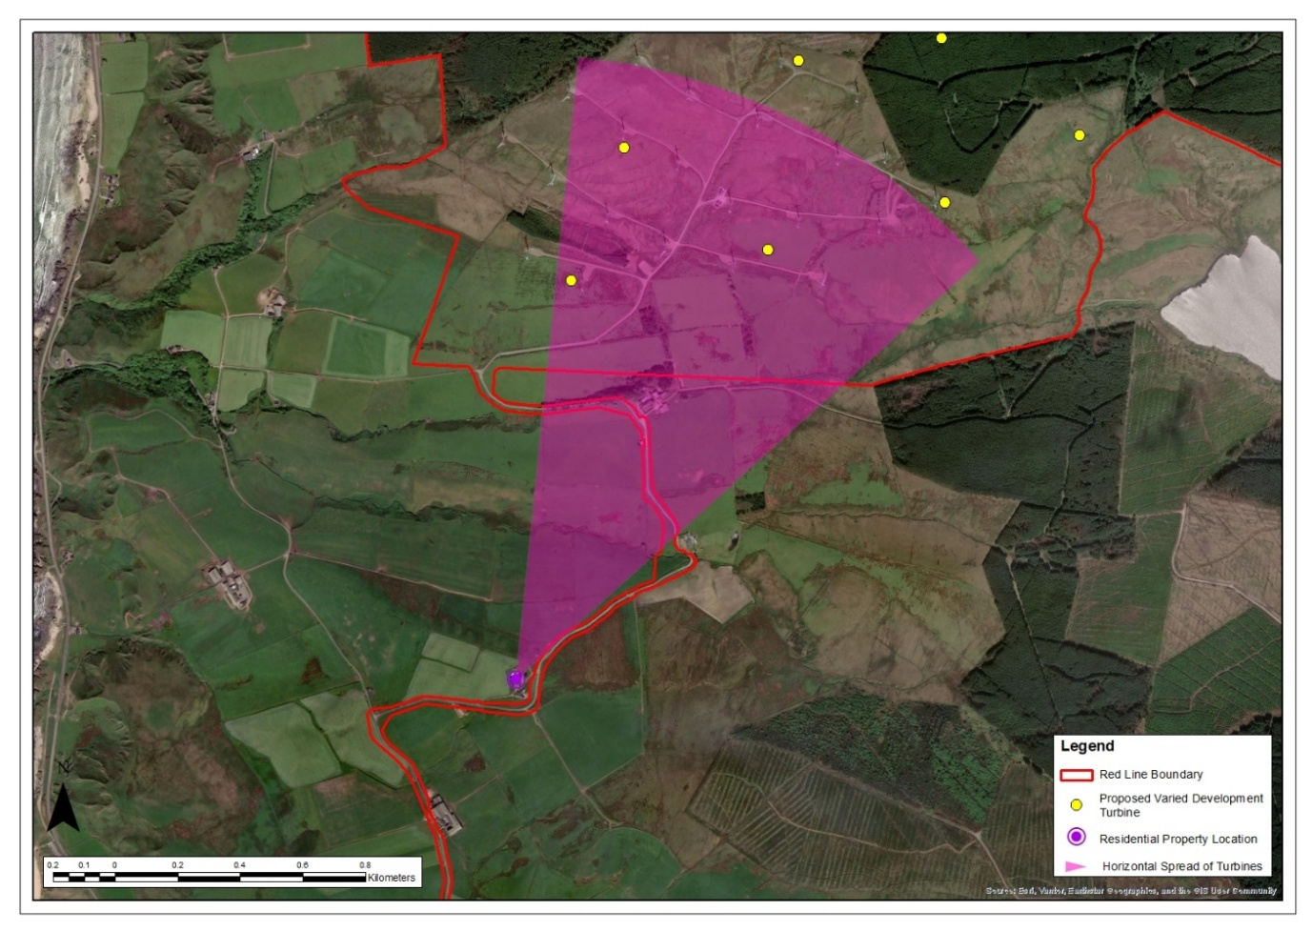
Breakachy (Number 5) – Aerial Image

Table 21: Property No 21: Breakachy (Number 6)
Property No 22: Breakachy (Number 6)
Grid Reference: 167067 626869  Elevation: 128.8m |  | Distance to Nearest Visible Turbine: 1.28km  Blade Tips Theoretically Visible: 16  Hubs Theoretically Visible: 16
Property Description
☐ Detached  ☒ Semi-detached  ☐ Terraced  ☐ Farmhouse | ☒ 1 Storey  ☐ 2 Storey  ☐ Stone Built  ☒ Rendered | ☐ Farmyard  ☒ Outbuildings  ☐ Conservatory  ☒ Garages |  | ☒ Front Garden  ☒ Rear Garden  ☒ Side Garden
Description of Baseline Visual Amenity  Main views from this property are orientated south and south-westwards with windows within the property accommodating these expansive sea views. Views from the side and rear garden are orientated directly towards the Operational Development across undulating agricultural land with conifer planting. There are clear views of the Operational Development in relatively close proximity although the garage may provide a small amount of screening.  Nature of Change  The Proposed Varied Development turbines would be clearly visible in rear views to the north. They would replace the existing turbines appearing noticeably larger. The aviation lights of five turbines would be theoretically visible during the hours of darkness.  Magnitude of Change: Medium - high  Significance of Effect: Significant |  |  | Residential Visual Amenity Threshold Assessment  The Proposed Varied Development turbines would not affect the property’s valued views to the west towards the sea. The turbines would feature prominently in rear views northward from the dwelling and the garden. They would be seen in a similar part of the view as the Operational Development turbines which they would replace but appear noticeably larger. The turbines would be prominent but would not introduce new features into views northward and would not dominate the visual amenity of the property, given that valued seaward views would not be affected. This is not considered to reach the RVAT.
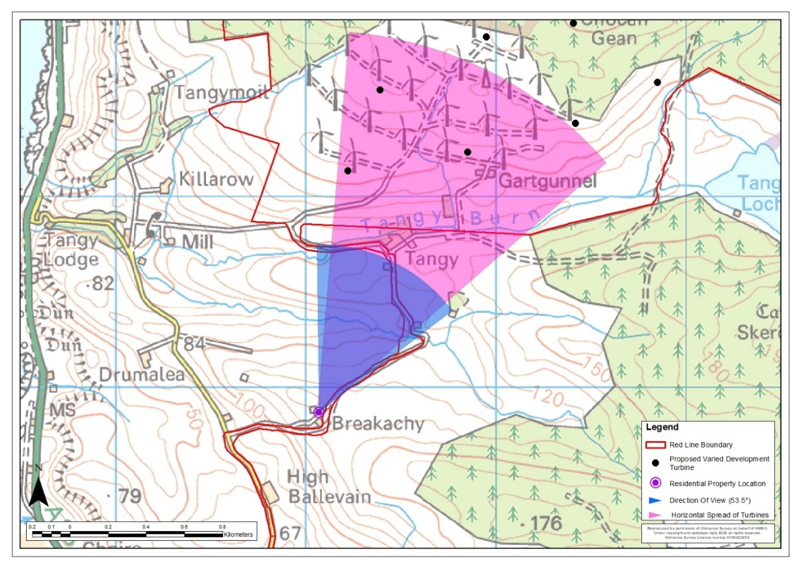
Breakachy (Number 6) – Location Plan
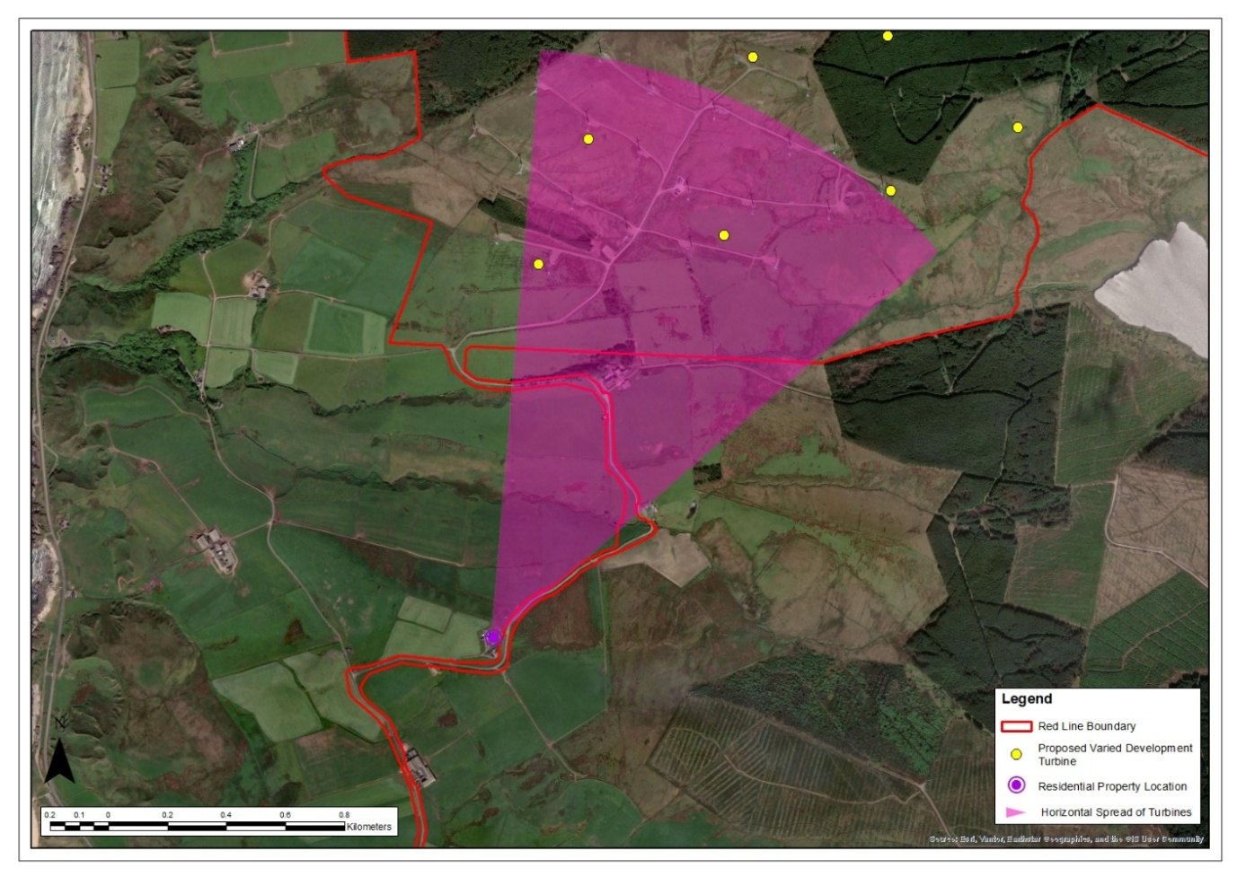
Breakachy (Number 6) – Aerial Image

Table 22: Property No 22: High Ballevain Farm
Property No 23: High Ballevain Farm
Grid Reference: 166805 626434  Elevation: 71.4m |  | Distance to Nearest Visible Turbine: 1.75km  Blade Tips Theoretically Visible: 4  Hubs Theoretically Visible: 1
Property Description
☒ Detached  ☐ Semi-detached  ☐ Terraced  ☒ Farmhouse | ☐ 1 Storey  ☒ 2 Storey  ☐ Stone Built  ☒ Rendered | ☒ Farmyard  ☒ Outbuildings  ☐ Conservatory  ☐ Garages |  | ☒ Front Garden  ☐ Rear Garden  ☐ Side Garden
Description of Baseline Visual Amenity  This property is a working farm occupying the side of a minor road. The property consists of a farmhouse, outbuildings and barns. Main views from the farmhouse are westward across agricultural land and towards the sea. Rear views to the north are very limited, contained by farm buildings and rising landform.  Nature of Change  Views of the Proposed Varied Development turbines would be screened from the dwelling itself. There may be views of a small number of blades to the northeast from the rear of the farm buildings. The aviation light of one turbine would be theoretically visible during the hours of darkness.  Magnitude of Change: Low  Significance of Effect: Not Significant |  |  | Residential Visual Amenity Threshold Assessment  The Proposed Varied Development turbines would not affect views from the dwelling itself including the main views west towards the sea. They would largely be screened in views north by farm outbuildings and rising landform. This is not considered to reach the RVAT.
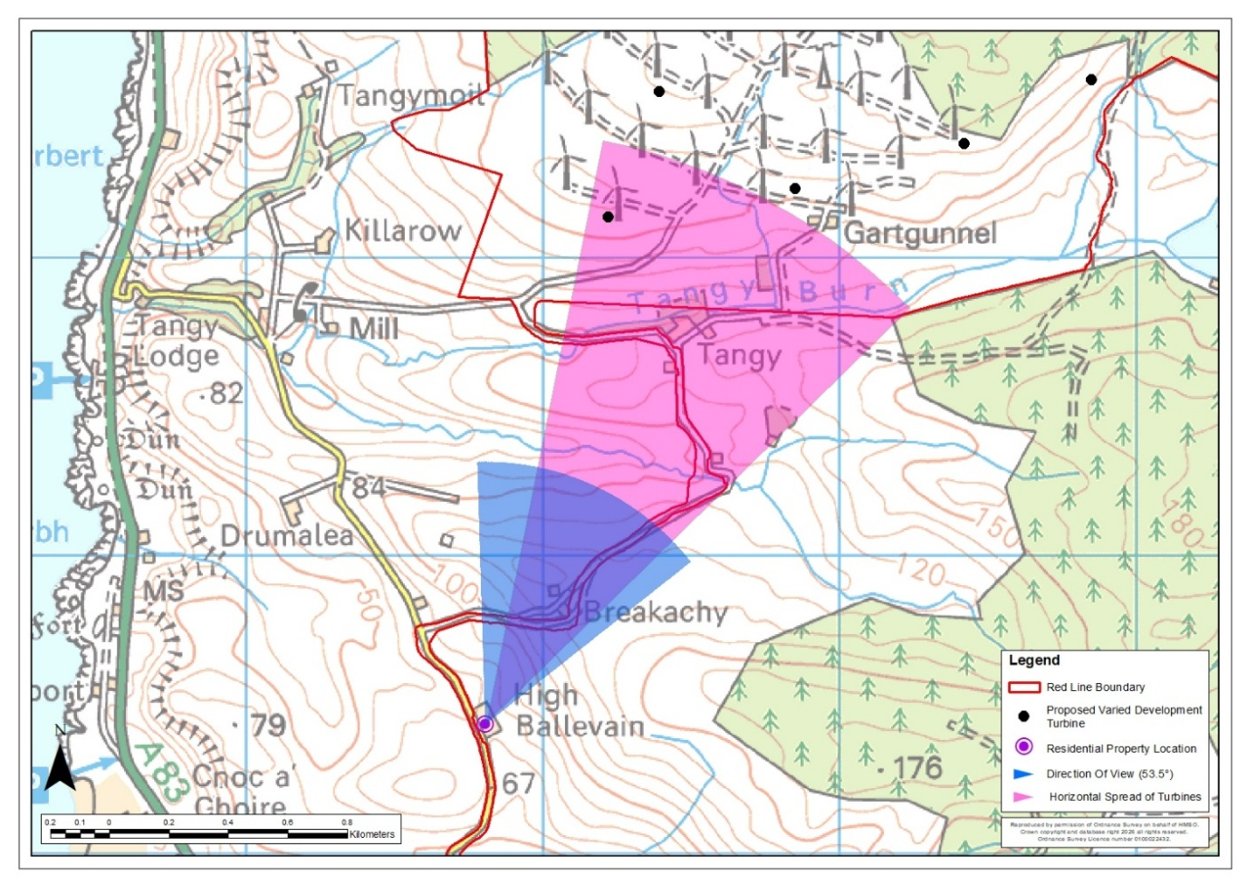
High Ballevain Farm – Location Plan
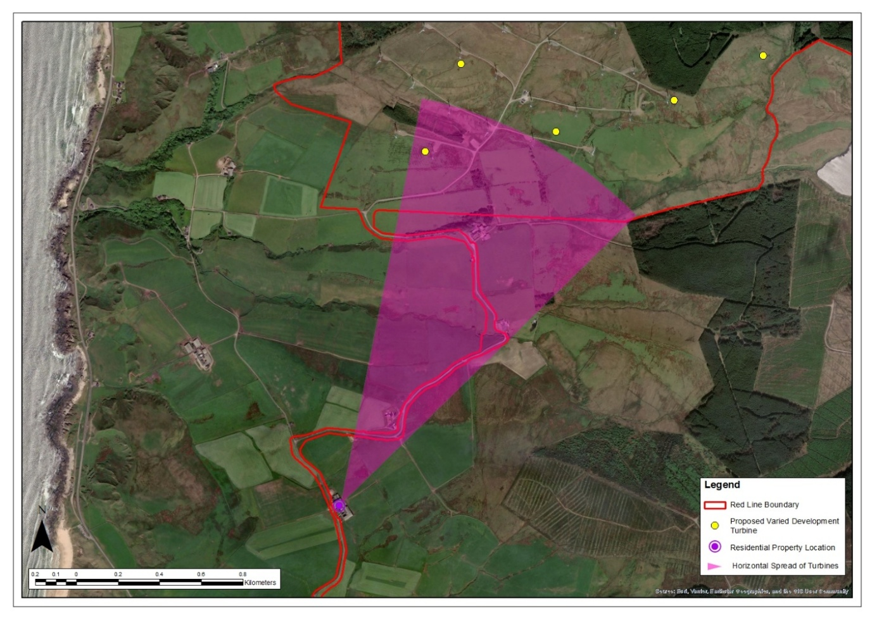
High Ballevain Farm – Aerial Image

Conclusion
    - This RVAA has identified that 19 residential properties would be likely to experience significant visual effects as a result of the Proposed Varied Development, while 3 properties would be likely to experience effects that are not significant. The occurrence of significant visual effects does not in itself mean that residential visual amenity would be impacted to such an extent that living conditions would be adversely affected. In many cases, the identified effects arise in relation to particular elevations, gardens or secondary views, while principal or valued outlooks remain unaffected or only partially affected by the Proposed Varied Development.
    - Having regard to factors such as the presence of the Operational Development, separation distance, the availability of alternative unaffected views, the extent of screening by landform, vegetation or built form, and the fact that the Proposed Varied Development would not generally appear overbearing, or overwhelmingly dominant, it is concluded that the RVAT would not be reached for the majority of the properties considered.
    - 1 property has been identified as potentially approaching the Residential Visual Amenity Threshold: Dalnaspidal / Hazel’s Cottage. This reflects the combination of relatively close proximity to the Proposed Varied Development, the orientation of the property and the extent to which turbines would be experienced from within curtilage of the property with limited potential for screening.

Landscape Institute (2019). Technical Guidance Note 2/19: Residential Visual Amenity Assessment. Available at: https://landscapeinstitute.org/technical-resource/rvaa/. Accessed on: 19 May 2026
Landscape Institute and Institute of Environmental Management and Assessment (2013). Guidelines for Landscape and Visual Impact Assessment, 3rd edition.

