February 2026 | SSE Renewables  Red Oak South  South County Business Park  Leopardstown  Dublin, D18 W688

Re: Proposed changes to Culliagh and Meentycat wind farms

Dear Householder,

I hope you are keeping well. We are writing to you on behalf of SSE as we would like to share some information in relation to proposed changes to the existing Culliagh and Meentycat wind farms, both of which form part of our cluster of wind farms in County Donegal.

As you may know, SSE operates 31 onshore wind farms in Ireland, making us the largest generator of renewable energy across the island. In Donegal, we have a long-standing presence through both our Culliagh and Meentycat wind farms. More recently, our neighboring Lenalea Wind Farm became operational in 2023, while our Drumnahough Wind Farm has just entered construction, with both of those projects being co-developed with FuturEnergy Ireland (FEI). See map overleaf for reference.

Culliagh Wind Farm’s 18 turbine have been operational for over twenty-five years, while Meentycat Wind Farm was Ireland’s largest wind farm when it became operational in 2004, with further extensions in 2009 bringing its number of turbines to 45 in total: 63 in total across both sites. Together, both wind farms constitute over 100MW of clean energy, powering Irish homes and businesses and eliminating harmful carbon dioxide emissions from Ireland’s electricity fuel mix. Furthermore, the annual Culliagh and Meentycat Community Fund has shared the value of renewable energy throughout the local community with over €1.7 million distributed via 857 individual grant awards to local projects since 2007. Both wind farms are also significant contributors to commercial rates, helping to fund improvements to infrastructure and services in County Donegal more widely.

To continue the provision of renewable energy at our Culliagh and Meentycat sites, and related community funding, we are now examining the potential to repower these wind farms – the proposed “Meentycat Energy Park”. In short, repowering would involve the dismantling and replacement of turbine equipment, with existing infrastructure on site such as roads and grid connection equipment being reused where possible. Repowering of these wind farms would also reduce the total number of wind turbines. In addition, repowering can provide several benefits including continuing the productive use of existing windfarm sites, significantly increasing the clean energy produced, increasing energy security, and is a cheaper alternative to new-build wind farms.

We are keen to work closely with the local community on this project and that is why we are writing to let you know about our plans at this early development stage. This initial letter is also part of a wider engagement plan with additional communication and consultation to take place throughout the year ahead.

In the meantime, if you wish to contact me to discuss any aspect of the proposed Meentycat Energy Park, or our separate Drumnahough Wind Farm which recently entered construction, please contact me via email or phone using the contact details provided below.

Seamus Herron, Community Liaison Officer, SSE Renewables

Email: clo@sse.com
Postal Address: SSE Renewables, Red Oak South, South County Business Park, Leopardstown, Dublin, D18 W688

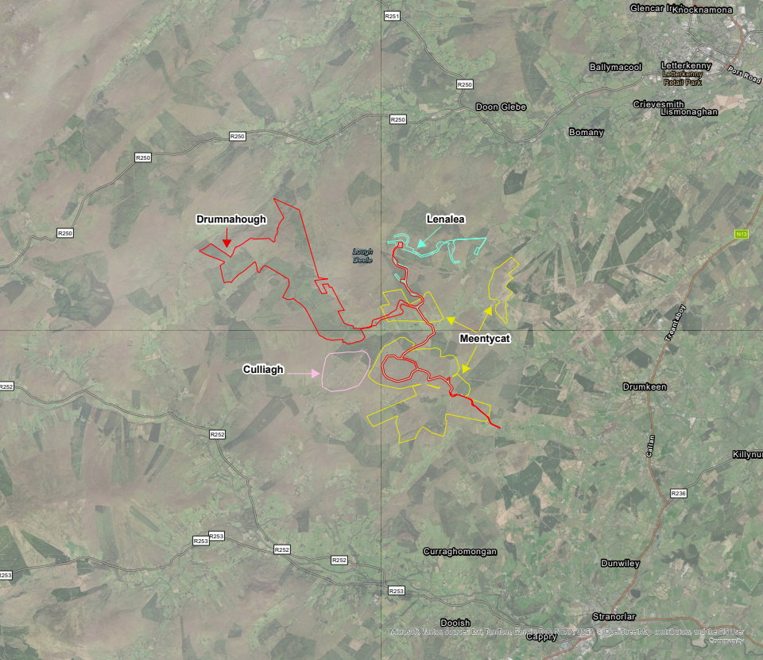

Map: Site boundaries of the respective Meentycat (SSE – operational since 2004, with extensions complete in 2009) and Culliagh (SSE – operational since 2000) wind farms. Also included are Drumnahough (SSE/FEI – in construction) and Lenalea (SSE– operational since 2023) wind farms. For reference, Letterkenny is located to the north-east of the wind farm cluster and Stranorlar to the south-east.

