About the Community Fund

SSE operates a 10MW wind farm near on the island of Sanday, in the Orkney Isles. The Spurness Community Fund has been established as a means of enabling us to contribute to the communities located around the wind farm. Starting in 2004, the Fund is worth approximately £30,000 per year.

The fund is open to applications from not-for-profit groups located within the following community council areas:

- The Community Council area of Sanday.

Advice and support
Kirsty Partridge, Community Investment Manager can provide further information on the fund. They can be contacted at kirsty.partridge2@sse.com@sse.com or

Application deadlines

The fund will close for applications four weeks before a panel meeting and decisions on applications are taken at Community Council meetings. Therefore, the schedule for the Spurness Community Fund panel meetings is in accordance with the Sandy Community Council Meetings.

What the fund can support
The Fund aims to support the following priorities:
- foster social networks & activities that support older people in the community
- assist young people to maximise their potential and improve their life chances
- promote better relationships between different generations
- encourage healthy lifestyles and good mental health
- support the development and use of new community assets, and maintain and enhance existing ones
- address the effects of rural isolation, improving access to services and improving transport
- support skills development and non-profit making initiatives that will nurture a thriving and diverse local economy
- minimises environmental impacts and reduces ‘carbon footprint’
- strengthen the ability of local people and groups to continue to meet their own needs and make a difference within their communities.

What the fund cannot support
The Community Fund will not support the following activities or costs:
- The advancement of religion or politics
- Activities that are the statutory responsibility of statutory authorities
- Projects benefiting primarily those residents outside the Fund Area of Benefit
- Activities contrary to the interests of SSE or its subsidiaries
- Activities likely to bring SSE or its subsidiaries into disrepute
- Anti-renewable energy/wind farm activities
- Retrospective funding (i.e. paying for costs incurred before a decision on an application to the Fund for support can be made)
- Recoverable costs (i.e. VAT costs that can be recovered).

Applying to the Community Fund

SSE operate an online Community Investment Portal. The portal ensures all applicant data is held securely and makes it easier for groups to apply for and manage grants.
- SSE recommend you prepare your answers to the questions offline and then copy them into the online application, the Community Investment Manager can provide a word template of the questions if this would help you.
- There are six stages to completing an application.
- You can view videos on navigating the SSE Community Investment Portal here.
- You can read Frequently Asked Questions about the SSE Community Investment Portal here
- If you have any problems in accessing or using the SSE Community Investment Portal, please contact the communtyfundsupport@sse.com

Accessing the Community Investment Portal - You can access the Spurness Community Fund Application here –

The process map overleaf visually outlines the application process for groups to become registered on the Community Investment Portal. The process is then outlined in more detail later in this document.
Guidance on the Community Investment Portal
Stage 1 – Fund webpage
- To access the correct application, you need to visit the fund webpage. If you are creating a new application, click ‘Begin New Application’ and then follow the steps below.
- If you have already created a draft application, please click ‘Continue Existing Application’ on the fund webpage, log in to your account, click ‘My Applications’ on the home screen, and then ‘launch’ next to your draft application.

Stage 2 – Eligibility
- When you access the Spurness Community Fund application for the first time you will be asked to answer some yes and no questions to ensure your project is eligible for the fund.
- If your project is not eligible you will be directed to where you can find information about other SSE community funds.
- If your project is eligible, you will be directed to log on to the Community Investment Portal to access or create your user account.

Stage 3 – Setting up a user account
If you have previously used the Community Investment Portal, please log in using your username and password, and progress to Stage 5.
If you have never used the Community Investment Portal before, you will need to create an account.
To create an account, click ‘not registered?’ and enter your name and email address. You will then receive an email to confirm that the account has been registered, containing your username.
IMPORTANT
Please note that your username will be your email address with .sse at the end (e.g. joe.blogs@outlook.com.sse).
Please click on the link in the email to create a password.

Stage 4 – Community Investment Homepage
Once you have created a password, you will be automatically redirected to the Community Investment Portal homepage.
To continue with your application, please repeat Stage One (go to the relevant fund page, click ‘Begin New Application’ and complete the eligibility questions). You will then be able to log in and continue with the below steps.

Stage 5 – Creating a group account
When starting a new application, you will be asked to select the group you wish to apply on behalf of. If you have already completed an application on behalf of a group previously, you can select the group from the drop-down menu.
If this is your groups first time applying on the SSE Community Investment Portal you will need to register a group account. This information will be stored and used for all future applications by the group on SSE’s Community Investment Portal.
IMPORTANT
You need to upload a copy of the group’s constitution at this stage– make sure you have this available before starting.
You need to do stage five in one attempt to create an account on the system.
To create an account, you will be asked the following questions:
Question | Guidance to answer question
Name of group | This should be the name that appears on your group’s governing document and bank account statement.
Type of group | You will be able to select from a list: Unincorporated voluntary or community organisation; SCIO; registered charity (other); Company limited by guarantee; Community Interest Company; Community Benefit Society; Community Council; Other  If your group has one, you will be asked to provide its registered charity and/or company number so please have this to hand.
Phone number | Please enter a phone number on which we can contact the group to discuss the application or grant.
Website
Number of people | - on your group’s board or management committee – in total, not just office bearers  - employed by the group  - who volunteer for the group.
Date Established | Please provide the date that your group’s governing document was adopted, or if it is a registered company or charity, the date it was registered with the regulator.
What are the groups aims and objectives?
What are the groups main activities? | Provide a summary of the main activities or services the group delivers and/or has delivered to-date.
Communities supported | State which communities or beneficiary groups your group supports. For example all residents in the community your group is set up to benefit, or young people, or people who are not in education, employment or training.
Constitution upload | Upload the latest version of your group’s governing document adopted by the members.
Correspondence address
Registered address | This is the address at which your group or organisation is formally registered, which may differ from the correspondence address.

Stage 6 -Application Form
You may prefer to prepare your answers to the project questions offline and then copy them into the application, The community investment manager can provide a word template of the questions if this would help you.
IMPORTANT
You need to upload a copy the following documents in stage two:
• A copy of one of the group’s bank statements from the last three months
• A copy of the group’s most recent approved annual accounts
• A copy of your project budget (or you can use the budget template provided in the application form)
• Copies of quotes for works or goods included in the project budget (if applicable)
• A copy of the organisation’s Child Protection/Vulnerable Adult Policy (if applicable)
• Letters of support for your project (if applicable)
• Any other documents which you think are required in support of your application. For example a business plan, and/or copies of any relevant permissions, such as planning permission.
PLEASE NOTE - due to GDPR we ask you not to include any photos which include people.
About the project
Question | Guidance to answer question
Please give a summary of the project or activity you are requesting a grant towards | The description should be no more than 25 words.
Please provide a postcode that best represents the project’s delivery location. | The geographic area the project will be delivered in.
Please provide a description of the project (maximum 3000 characters) | We suggest you cover:  - What you want to do.  - How you will do this – e.g. the activities you will deliver, where/ when/ how often you will deliver them, how you will reach those you are seeking to benefit, any equipment needed, and how it will be used  - How the community has been and/or will be involved in developing and delivering the project  - Who will lead the project – their role(s), skills and experience  - How you will monitor and evaluate the success of the project  - The proposed start and end dates for the project.
How will you maintain / sustain your project after the period of our grant funding is finished? (maximum 3000 characters) | - If the project will continue beyond the period for which you are seeking grant funding, please let us know how you intend to continue it, including how you will secure any funding, volunteers, or other resources needed to do so.  - Please also include relevant details if the project will help to make your organisation more self-sustaining.
How have you identified a need for this project within the local area? (maximum 2000 characters) | - Your project should address a current need and gap in local provision.  - Where possible please provide relevant local data that demonstrates this e.g. from a local community plan, survey of your intended beneficiaries, labour market statistics, and/or neighbourhood statistics.
How many people will benefit from the project? (maximum 1200 characters) | Only include those who will benefit directly from the project. This may include any volunteers involved in delivering it. Please ensure the number you give is realistic.  Please tell us how you arrived at this figure.
Will any jobs be supported by the project? | If yes, we will ask how many.
Will any community assets (e.g. community hall, footpath) be built and/or improved as part of the project? | If yes, we will ask how many.
Will this project help improve energy efficiency or climate change? | If yes, please provide details of the energy generation or carbon reduction potential of the project, where you know this.

UN Sustainable Development Goals
SSE’s community programme support the UN Sustainable Development Goals. We will ask you to identify the primary UN Sustainable Development Goal that your project contributes to and will allow you to also identify secondary goals. You can find out more about the UN SDG’s at: Sustainable Development Goals | United Nations Development Programme (undp.org)
UN Sustainable Development Goal | Example
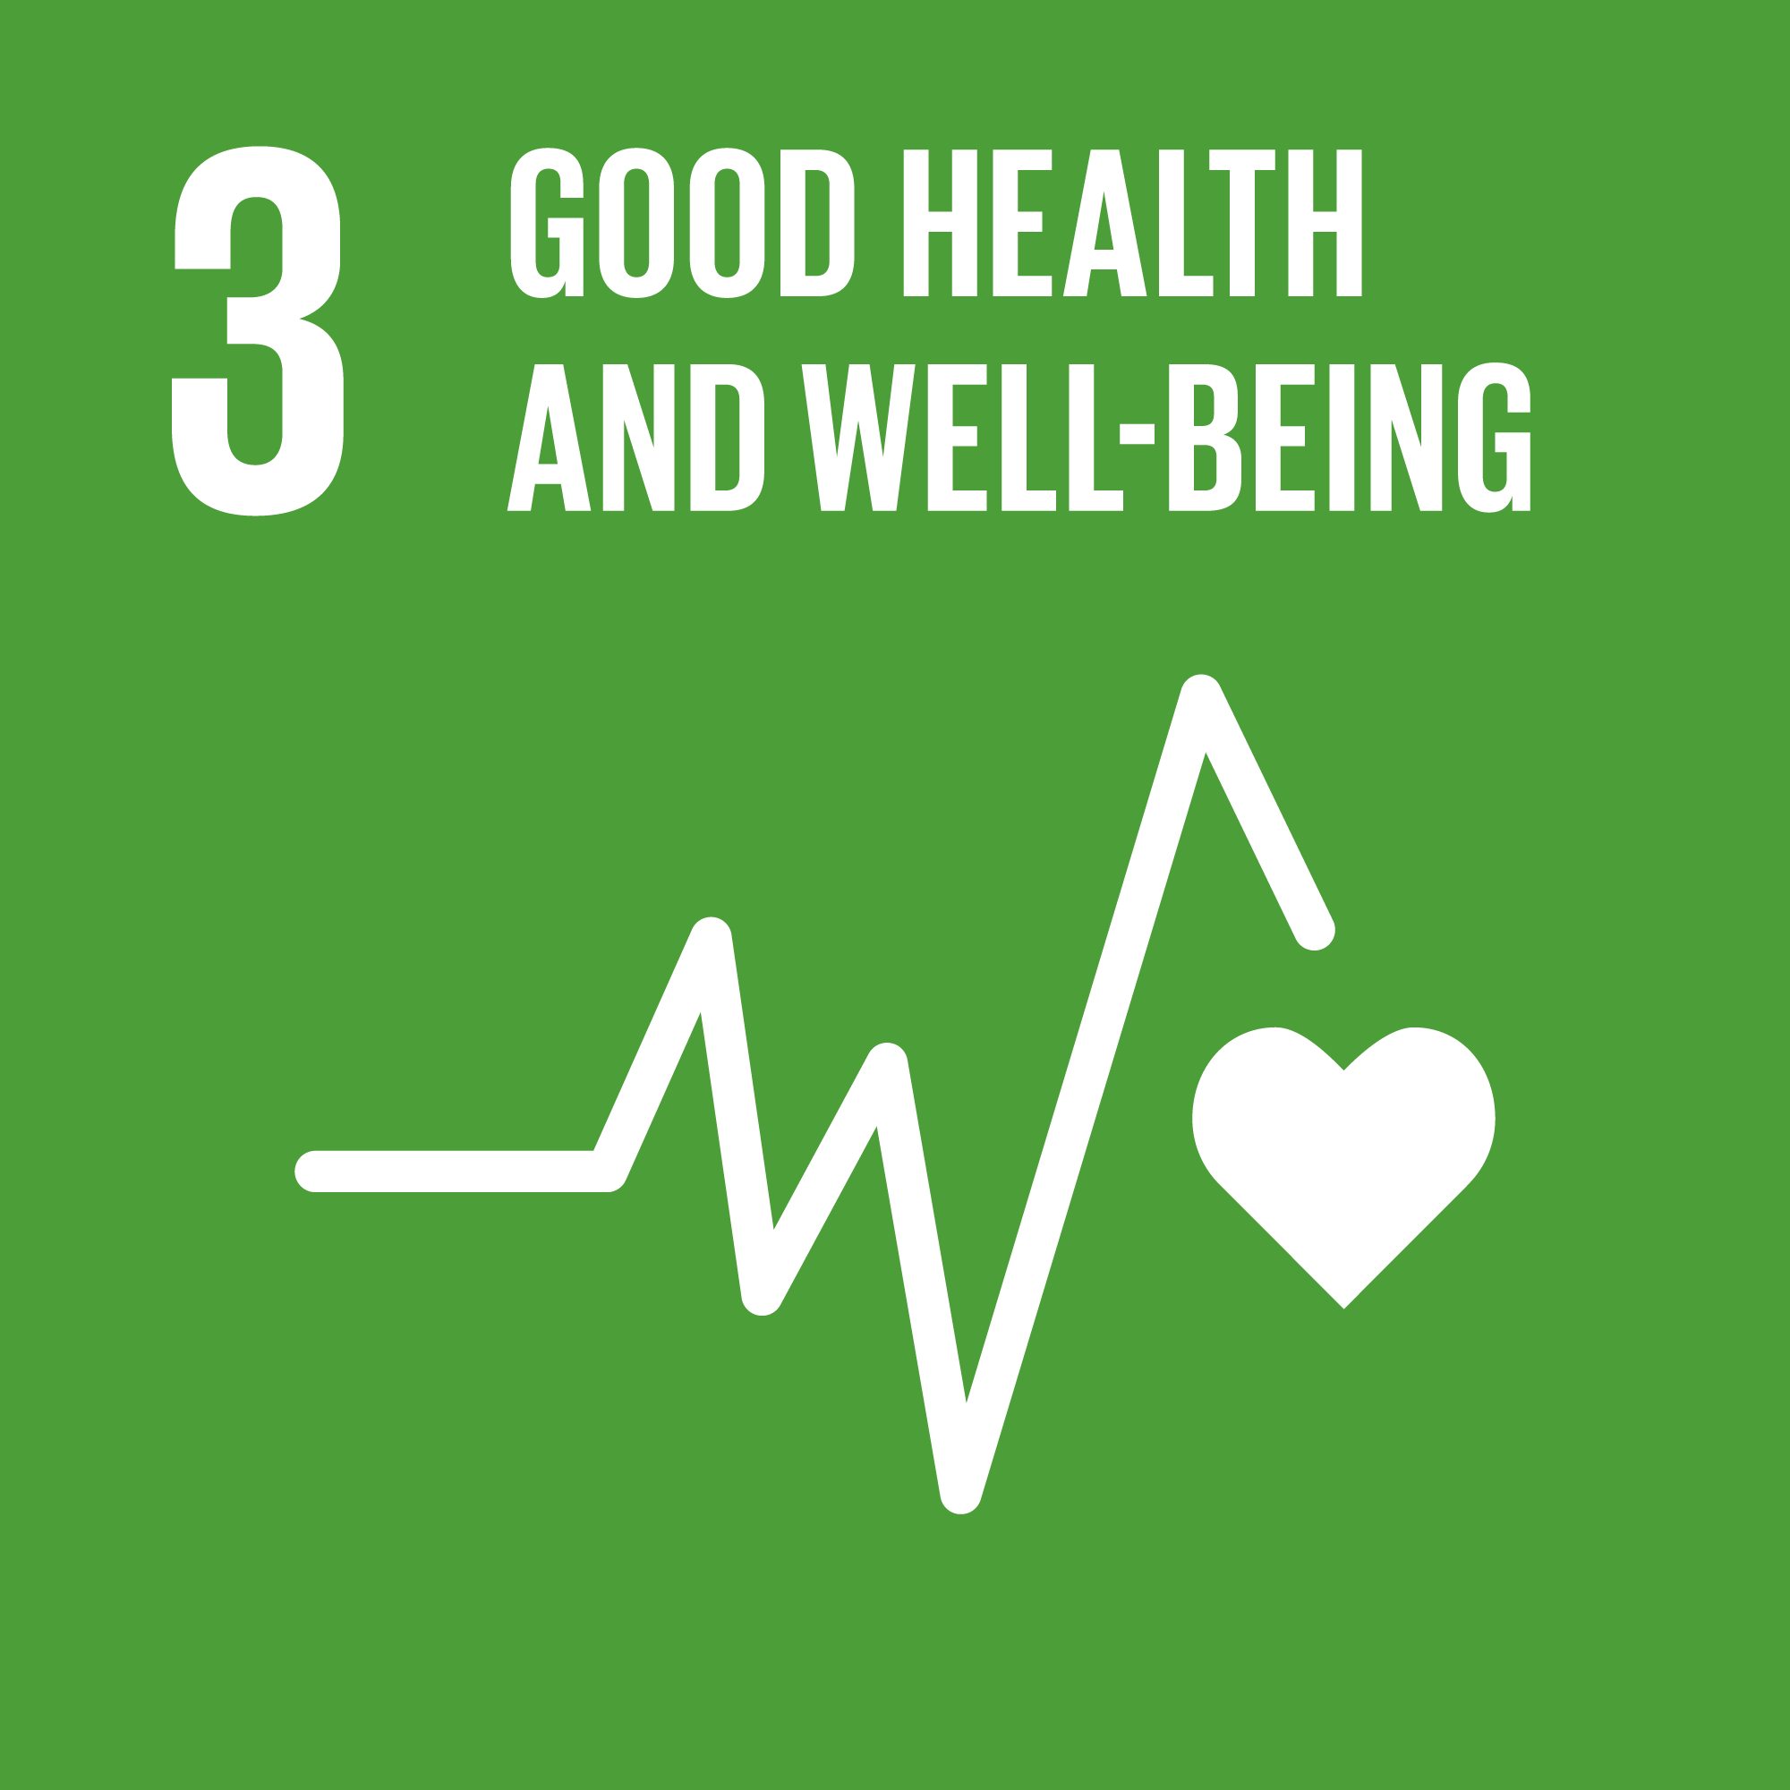 | Your project will improve people's well-being, physical health or emotional health e.g. community care services, sports classes, befriending services.
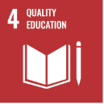 | Your project will support people to enter work, will help schools to deliver new activity or would help community members learn new skills.
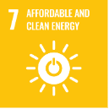 | Your project helps communities to have affordable and modern energy e.g. insulation measures, new heating systems.
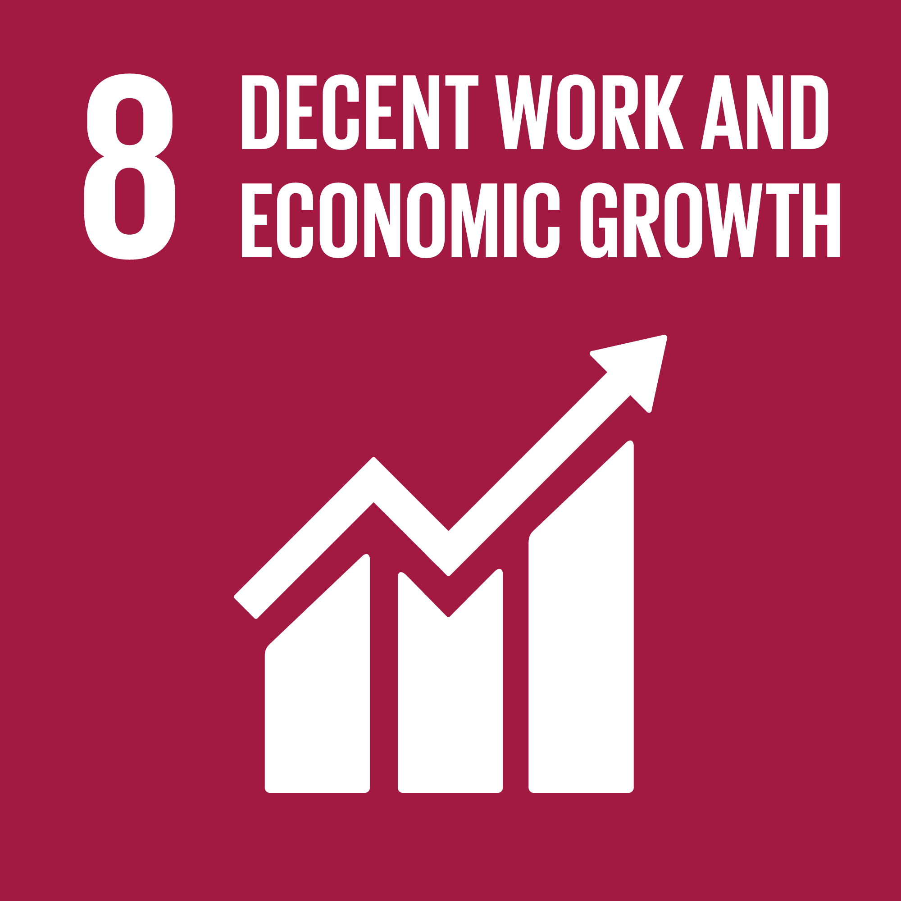 | Your project will enhance the local economy e.g. projects which employ people in the local area, the development of social enterprise activity, projects to increase tourism to the area.
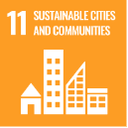 | Your project will help enhance the local community e.g. improving a community hall, building new community sports Centre, running a community event.
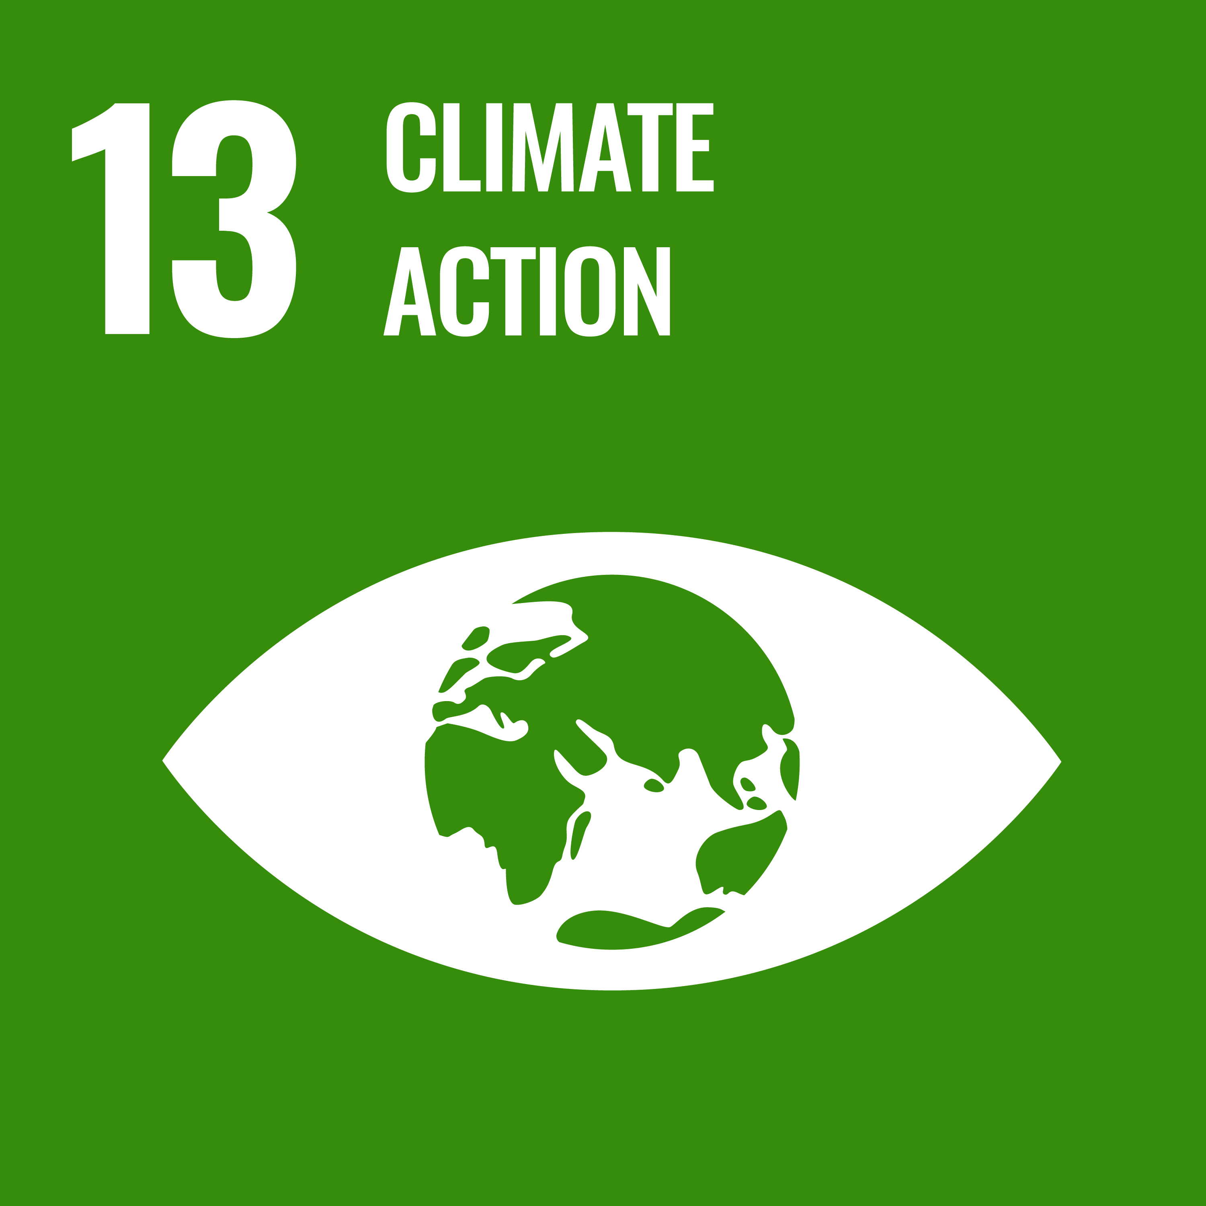 | Your project will help to combat climate change e.g. community renewables.
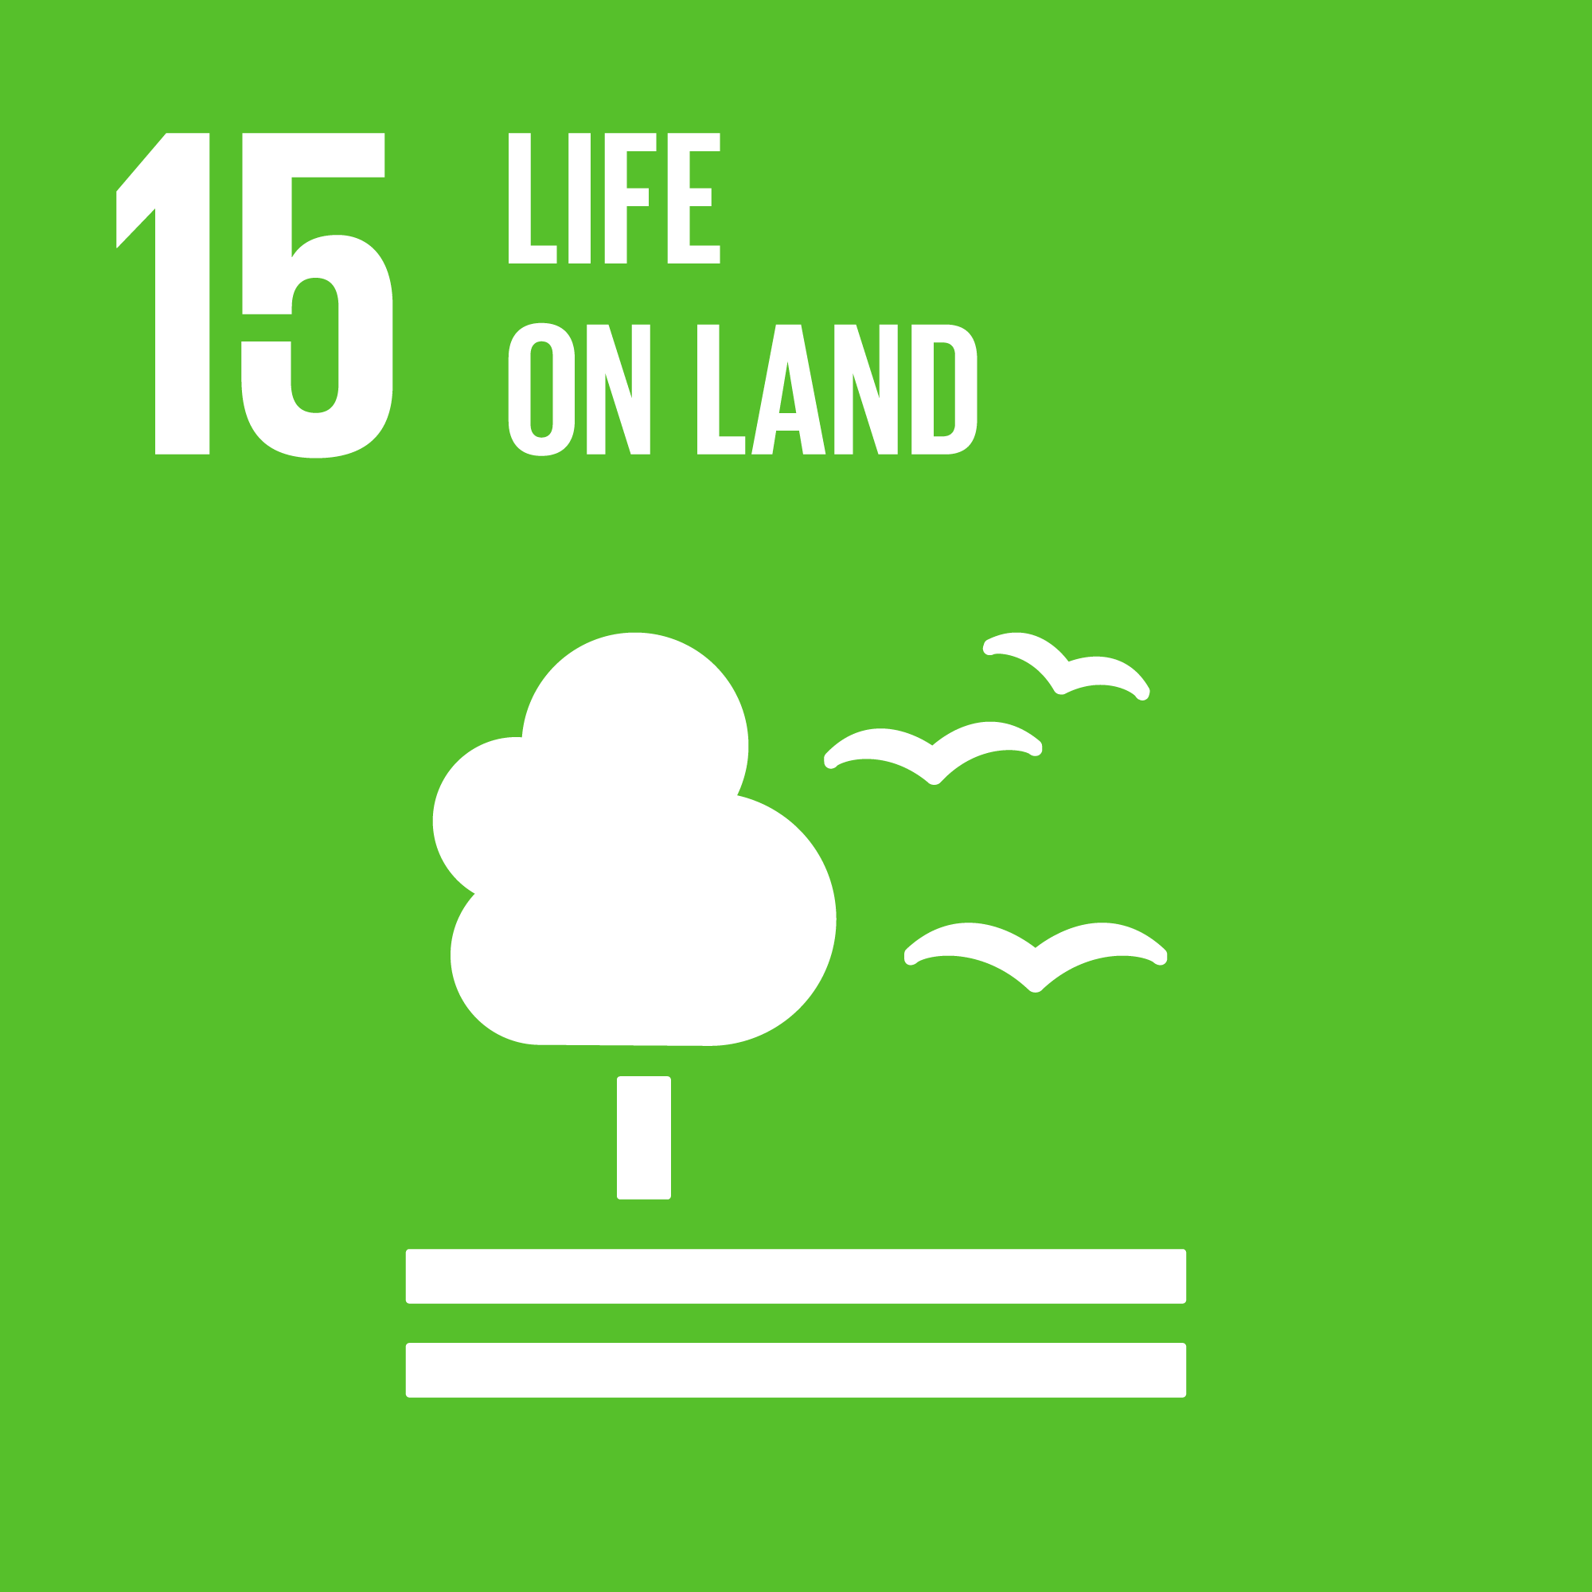 | Your projects which help the local environment e.g. community owned forests, community gardens, community nature paths.

Project Aims and Success
Question | Guidance to answer question
Please explain how your project achieves the Fund aims and priorities outlined on page 1 of this guidance document. (maximum 4000 characters)

Project Bank Details and Group Finances
Question | Guidance to answer question
Bank account holder’s name | This is the name that your group’s bank account is held in, as it appears on bank statements - it should be the name of your group.
UK FUNDS  Sort code  Account number | Please ensure the details you provide here are correct as this information will be used to make grant payments if you are successful in securing a grant.
Upload a copy of a recent bank statement | This should be from the last 3 months  This is a mandatory field on the form so please make sure you have the statement available before starting the application.
Upload a copy of the group’s latest accounts | This should be the version approved by the group’s board or management committee.  This is a mandatory field on the form so please make sure you have the statement available before starting the application.
Name, email address and position of an additional authorised bank signatory | You need to provide the details of a second person who is authorised to use your group’s bank account.  Please ensure you enter these details correctly as this person will be e-mailed any grant offer letter for their countersignature.
What are the main sources of income for the group? (maximum 1200 characters) | Provide brief details of how the group normally raises most of its income e.g. from local fundraising, grants, charges for services, etc
Total income and surplus/deficit from the uploaded financial accounts | The figures you provide should match those in the group’s approved annual accounts that you uploaded earlier as part of your application
Current unrestricted reserves and why they cannot be used for this project (maximum 2000 characters) | Unrestricted reserves are monies which are not restricted (usually by a donor or lender) for any particular use. If your group’s unrestricted reserves cannot be used towards the project you are seeking a grant from SSE for, we will ask you to explain why.

Project Budget
Question | Guidance to answer question
Please provide an accurate list of all costs involved in the work, services, or items required for the project. This should include any project costs that you are not requesting a grant towards. | You will be able to select one of two option to add your project cost detail. Please do not do both.  - Insert the information into a list/ table in the form  - If you enter costs in the list / table option, these will automatically be totalled.  OR  - Upload your own budget template.  - If you choose to upload a budget file, enter the total project cost (as stated in the file) into the box provided.
Please explain how you have costed the project. (maximum 1500 characters) | - For larger capital items (e.g. building work, vehicles, equipment) of more than £2,500 in value we expect you to have sought at least two quotations, for such items of more than £10,000 in value we expect you to have sought at least three quotations. Please upload any quotations you have received towards such costs.  - If you are seeking a grant to cover salary costs, please tell us what hourly rate will be paid. SSE is a Living Wage Friendly Funder; therefore, we require any roles paid for through our funding to meet or exceed the Living Wage.
Tell us how much you are applying to the Spurness Community Fund for. | Only non-recoverable VAT costs should be included in any grant amount you are requesting from SSE.
Who are the project funders? | If your total project cost requires other funding (including where your organisation is contributing its own funds), you will be asked to list all of the other funding sources, including the amounts being applied for and whether this funding is confirmed.

Checklist
We will ask you to tick yes, no or not applicable to the following checklist:
- That the group has the appropriate procedures in place to carry out your project safely
- That the group has at least three unrelated people serving on its management committee / board.
- That the project doesn’t require retrospective funding
- That, if requested, you can provide the details of an independent referee.
- That any salaries are paid at, or greater than, the Living Wage
- Whether the project requires your group to secure permissions, such as planning permission, a building warrant and/or listed buildings consent, prior to starting work. If it does, tell us whether these have been applied for / granted. If they haven’t been applied for or granted yet, tell us when you expect this to happen.

Submitting the form
Your draft application will save at key points, so you can log out of the portal and resume drafting at a later date.
To continue drafting, click the ‘Continue Existing Application’ link on the fund homepage, click the ‘My Applications’ button on the home screen, and then ‘launch’ next to your draft application.
If you have any problems in accessing or completing the application form, please contact us on the details below. You can also read our dedicated SSE Community Investment Portal FAQ section.
Once you have completed your application form, press the submit button. A copy of your application form will be saved in your ‘My Applications’ section of the portal.

